Application for Admission to Berkswich CE Nursery

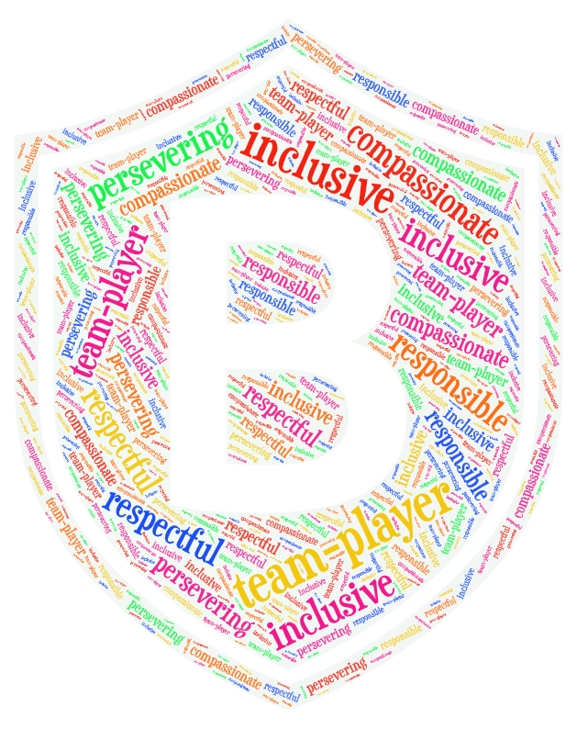Thank you for applying for a place at Berkswich CE Nursery. We manage our own admissions and, therefore, before completing this initial application form, please read the Nursery Admission Policy provided on our website at www.berkswichceprimary.co.uk/statutory-policies-and-documents/. Our Welcome to Nursery booklet (https://www.berkswichceprimary.co.uk/welcome-to-nursery-information-booklet/) is an essential read, full of information about funding, available provision and starting early. Paper copies of both of these are always available on request from the office. You are warmly invited to contact the school office (01785 337360) to discuss your requirements further.

An online form is available from
https://forms.office.com/Pages/ResponsePage.aspx?id=RvUD9cnCqk2azGDP7UNM8Ihgcbn3O2FMhqGbvR9wBalURVFBTUNKS1lOVEhBNkFGUFdVQ1MzVDIxUC4u

*** Please complete in block capitals. For twins, two forms must be completed. ***

Child’s First Name (as on birth certificate) |  | Date of Birth
Child’s Preferred First Name |  | Child’s Surname
Gender and referred pronoun (she, he, they, etc.) |  | Age when joining nursery (3 years or 4 years)
Will you have another child in school at the time when your child starts Nursery? | Yes/No  Please delete as appropriate | Names/years of siblings in school
Name and address of previous and/or current nursery
Full postal address, including postcode

- Does your child have an Education, Health and Care Plan (EHCP)? Yes/No (please delete)
- Is your child in the care of a local authority? Yes/No (please delete)
- Has your child previously been in the care of a local authority but has since been adopted (or become subject to a residence order or special guardianship order since being in care)? If ‘Yes’ to either of the above, then please provide full Social Worker and Local Authority contact information below.

- I would like/would not like to receive our weekly newsletter, packed with the children’s latest adventures at Berkswich (please delete. You can ask to stop receiving these at any time).
Title, first and surname of parent/carer completing the application |  | Title, first and surname of second parent/carer
Preferred pronoun (she, he, they, etc.) |  | Preferred pronoun (she, he, they, etc.)
Relationship to child |  | Relationship to child
Contact number |  | Contact number
Email |  | Email

Provision Requirements
Please underline or circle when you would like your child to start in Nursery:

Autumn (September) 2026 Spring (January) 2027 Summer (April) 2027

Other (please state):

Please see the school’s Nursery Admissions Policy and the Welcome to Nursery booklet before completing the table with your expected provision requirements (see links above or visit our Nursery Admissions page on our website: https://www.berkswichceprimary.co.uk/nursery-information-and-admissions/).

To ensure continuity of provision, we would encourage children to attend five morning or afternoon sessions each week, however we understand parental preference regarding sessions. Please contact school for more information.

Please tick to indicate your preferred Nursery and wrap-around requirements
 | Cedars before school | Morning session | Lunchtime | Afternoon session | Cedars afterschool
Monday
Tuesday
Wednesday
Thursday
Friday

It would be useful to know how you intend to fund the Nursery place. Please tick all that apply.

Funding Options | Please tick all that apply
15 hours Nursery funding
30 hours Nursery funding
Self-funding
Tax-free childcare
Other (please state)

Please return your application form to office@berkswich.staffs.sch.uk or via the school office. School will acknowledge receipt of all forms by email within five working days of receipt. Please contact school if you do not receive confirmation within this time, since this may indicate that your form has not been received.

Office use | Receipt of form
Office use | Certificate seen:

