Cedars Before and After School Club  at Berkswich CE Primary School |  |  |  | 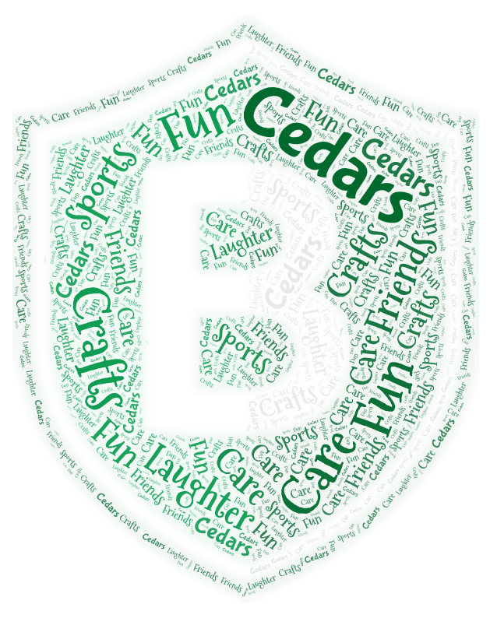
Reference Number  C20 |  | Shared with Staff  May 2024 | Ratified by  Governing Board  May 2024 |  | Review Date  May 2025
Policy Title | Cedars Payment, Fees and Booking Policy

Statement of intent
Berkswich CE aims to provide a wrap-around experience for children that is affordable and of the highest quality, offering a club in which children are safe, happy and excited to attend.
This policy has been established to provide transparent booking and fee information, set procedures for the payment of fees and create a framework for dealing with non-payment in a swift and fair manner.
We will work with parents to claim benefit entitlement related to childcare fees such as free childcare entitlement.
Parents should be aware of, and given access to, this policy. It will be included on the school’s website and made available to view at the school on request. For parents or carers to book sessions or use the provision for their children, they must agree to the terms set out in this policy, including those related to late collection and late payment fees.

Legal framework
  - This policy has due regard to legislation and statutory guidance including, but not limited to:
- Childcare Act 2006
- Childcare Act 2016
- The General Data Protection Regulation
- Data Protection Act 2018
- The Local Authority (Duty to Secure Early Years Provision Free of Charge) Regulations 2014 (as amended)
- The Childcare (Early Years Provision Free of Charge) (Extended Entitlement) Regulations 2016 (as amended)
- DfE (2018) ‘Early years entitlements: operational guidance’
- DfE (2018) ‘Early education and childcare’
- Debt Collection Policy

Registration
Children must be registered prior to using the wrap-around services at Cedars; school registration does not constitute Cedars registration. At the point of registration, parents are required to acknowledge that they have understood the terms and conditions contained in this policy as a prerequisite for completion of registration.

Fees
The most recent Cedars charges can be found on the school website in the Cedars area which can be accessed from the Parent tab: www.berkswichceprimary.co.uk.

Where parents are self-funding (i.e., not paying from 15 or 30 hour government funding), then there is a discounted rate for a second child attending Cedars. If parents are using government funding, then they are charged for care provided outside of the following provision:

- Universal 15 hours free provision a week for all three to four-year-olds
- Extended 30 hours free provision a week for eligible three to four-year-olds
- Extended 30 hours free provision a week for children in foster care

Fee increases

Cedars fees continue to be highly competitive when compared to those charged in other local settings. The governors reserve the right to amend Cedars fees and will give one month notice in the event of any changes.

Booking
Bookings must be made every month in Schoolcomms, a month in advance of use of the sessions. It is the parents/carers responsibility to ensure that this has been completed in time. Staff members are always available to support if there are technical difficulties.
Regular use of certain sessions or repeated patterns in bookings cannot be accepted instead of an actual booking for any month (i.e., it may be that you have the same days and hours of booking all year around; but in this situation, you must still book your sessions via the app a month in advance.).
Errors made in booking are the responsibility of the parents/carers; staff will endeavour to support parents in the event of such an error. However, Cedars/school is not obliged to rectify an error if staffing levels and booking numbers do not allow this at the point of the discovery of a booking mistake.
Emergency sessions or late bookings are to be booked in extreme cases only; the acceptance of these bookings will also depend on the numbers already booked and the essential number of staff need to ensure that levels of staffing are appropriate for the number or groupings of children. The final decision will only come from the Cedars manager and so any requests for this must be made directly to the manager (cedars@berkswich.staff.sch.uk). All provision booked as emergency sessions will incur an additional fee of £2 per child per session. This fee will be added automatically to the invoice at the end of the month.
Payments (including non-attendance)
Invoices received by parents will be paid through Schoolcomms Gateway by 15th of each month.
Cancellation of pre-booked places must be made with one week’s notice; otherwise, the costs of the sessions booked will still be charged.
Full payment is still required for pre-booked sessions when a child is then on holiday or absent due to illness, as Cedars will hold booked sessions during this period.
If a child is absent for a long period due to illness, Cedars will decide on a case-by-case basis as to whether fees will need to be paid for the period. This decision will be made by the headteacher.
Staff Fees
Berkswich CE school or Cedars staff members are able to book at a reduced rate. This fee is reviewed by Governors regularly and a month’s notice will be given for any price increases. Staff members must also complete a registration form, book in advance for all sessions used and agree to the terms set out in this policy.
Late collection
If a child is collected late by ten minutes or more, this can lead to staff needing to stay beyond the end of their shift. This incurs a cost, which will be passed on to the parents at a rate of a half hour session if pick up is delayed by ten minutes. Further charges will be added at a rate of £1 for each subsequent 5-minute period. Late collection payment fees will automatically be added to the parents’/carers’ next Cedars invoice.
These costs may be waived in exceptional circumstances at the discretion of the headteacher or the governing board. In these instances, the reasons for waiving the fees will remain confidential between school and the family concerned.

Late payments and difficulty with payments
The school will work with parents to ensure all avenues for assistance with payments are explored; for example, support will be offered to help an eligible parent to access 30 hours funding for those below school age.
Parents may face financial difficulties and, understandably, would like to ensure as little disruption to their child’s care as possible. Parents and carers experiencing such difficulties must contact the Cedars manager as early as possible in order for school to be informed and for staff to provide signposting to potential funding options (for example, working tax credit and 30 hours funding).
Invoices are to be paid by 15th of each month. Late payments will incur an automatic £30 fine for each month’s payments overdue. Parents can avoid this by ensuring the timely payment of fees each week. Late payment fees will automatically be added to the next Cedars invoice. School will remind parents about the payment date two days prior to the 15th of each month; however, school cannot be held responsible if this has not been received and payments are not made in time. It is solely the parents and carers responsibility to make prompt payment before or on the 15th of each month.
If payments are either two months in arrears or the arrears exceeds £200, parents and carers will no longer be able to use Cedars and the child’s place will be terminated. Outstanding debts from previous academic years must be paid before a place is booked for the following September.
Holiday clubs
This policy extends to holiday club provision. Pre-booking is essential to secure a holiday place. Payment must be made by the date stated in the holiday club information issued from the office or the Cedars manager. We reserve the right to refuse late applications. Places will not be held open for late payers. Late payment or late collection fees will continue to be applied if necessary during holiday periods. Non-attendance of booked places due to illness, holidays or as a result of unacceptable behaviour will still require payment; refunds will not be given for missed sessions unless in exceptional circumstances and agreed by the headteacher or governing board.
Debt collection
The governing board has a duty to ensure the school receives all the funds to which it is entitled, including Cedars fees. Debt collection for Cedars unpaid invoices will be carried out in line with the school policy for debt collection.
  - A full record will be kept of debts owed to the school for seven years. This will include all letters requesting money, reminders and invoices.
  - The school will not initiate legal action to recover debts; however, school will refer uncollected debts to the Staffordshire County Council to undertake such action.

Exceptional circumstances
In the event of a school closure, which is beyond the control of Cedars management or the governing board, payments already made will be returned by the school and sessions not yet paid for will be cancelled and not charged for. This will include inclement weather days or unplanned school closures.
  - Monitoring and review
  - This policy will be reviewed on at least a bi-annual basis by the headteacher, Cedars manager and the bursar, in conjunction with the approval of the school’s governing board. This will be reviewed sooner if there are any alterations in systems, fees or payment processes.
  - Useful links
- https://www.gov.uk/tax-free-childcare
- Childcare Choices | 30 Hours Childcare, Tax-Free Childcare and More | Help with Costs | GOV.UK
- https://www.gov.uk/apply-free-childcare-if-youre-working
- (news regarding changes to foster carer allowances: Free childcare to be extended to foster carers for the first time - GOV.UK (www.gov.uk))

