
Parables What stories did Jesus tell?

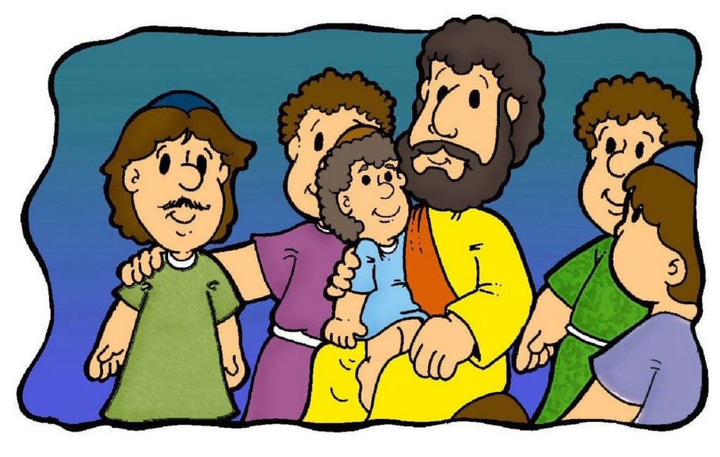

Read: ¹¹ Then Jesus said, “A man had two sons. ¹² The younger son said to his father, ‘Give me my share of the property.’ So the father divided the property between his two sons. ¹³ Then the younger son gathered up all that was his and left. He travelled far away to another country. There he wasted his money in foolish living. ¹⁴ He spent everything that he had. Soon after that, the land became very dry, and there was no rain. There was not enough food to eat anywhere in the country. The son was hungry and needed money. ¹⁵ So he got a job with one of the citizens there. The man sent the son into the fields to feed pigs. ¹⁶ The son was so hungry that he was willing to eat the food the pigs were eating. But no one gave him anything. ¹⁷ The son realised that he had been very foolish. He thought, ‘All of my father’s servants have plenty of food. But I am here, almost dying with hunger. ¹⁸ I will leave and return to my father. I’ll say to him: Father, I have sinned against God and against you. ¹⁹ I am not good enough to be called your son. But let me be like one of your servants.’ ²⁰ So the son left and went to his father.
“While the son was still a long way off, his father saw him coming. He felt sorry for his son. So the father ran to him, and hugged and kissed him. ²¹ The son said, ‘Father, I have sinned against God and against you. I am not good enough to be called your son.’ ²² But the father said to his servants ‘‘Hurry! Bring the best clothes and put them on him. Also, put a ring on his finger and sandals on his feet.

The Parable of the Lost Son

The Parable of the Lost Son
Read: ²³ And get our fat calf and kill it. Then we can have a feast and celebrate! ²⁴ My son was dead, but now he is alive again! He was lost, but now he is found!’ So they began to celebrate.
²⁵ The older son was in the field. As he came closer to the house, he heard the sound of music and dancing. ²⁶ So he called to one of the servants and asked, ‘What does all this mean?’ ²⁷ The servant said, ‘Your brother has come back. Your father killed the fat calf to eat because your brother came home safely!’ ²⁸ The older son was angry and would not go in to the feast. So his father went out and begged him to come in. ²⁹ The son said to his father, ‘I have served you like a slave for many years! I have always obeyed your commands. But you never even killed a young goat for me to have a feast with my friends. ³⁰ But your other son has wasted all your money. Then he comes home, and you kill the fat calf for him!’ ³¹ The father said to him, ‘Son, you are always with me. All that I have is yours. ³² We had to celebrate and be happy because your brother was dead, but now he is alive. He was lost, but now he is found.’”
Luke 15:11-32

What is the father thinking?
What is the son thinking?
Write your ideas in the thought bubbles.

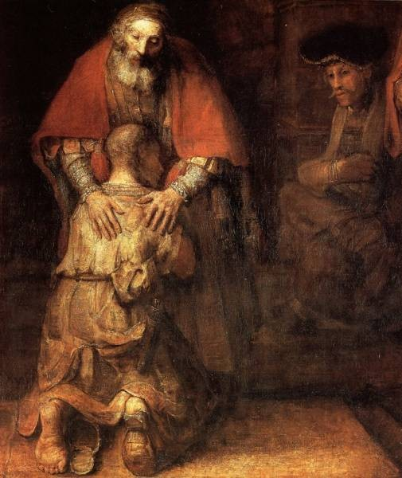
Who was your favourite character?

Christ
What might the story teach Christians about what God is like?
How did the story make you feel?
What surprised you about the story?
What do you think was the most important moment?
Christian prayers have four main types: praise, saying sorry, saying thank you and asking for something.
Peter Praise
Suzy Sorry
Thea Thanks
Andrew Ask





The story of the Lost Son might lead Christians to think it very important to say ‘Peter Praise’ prayers and ‘Suzy Sorry’ prayers.
What might a Christian say in a time of prayer? Have a go at writing your own prayer.
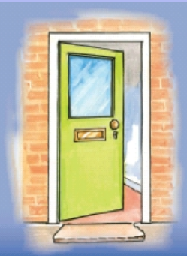
Inside the parent/carer, draw or write what parents/carers do to show they love their children.
Inside the child, draw or write what children do to show they love their parent/carer.


The story of the ‘Lost Son’ teaches Christians that God is loving and forgiving like a parent.

What happens in school if you do something wrong? How do you have a fresh start?
What happens at home?

Write or draw examples of forgiveness.

Draw or write your ideas.
CHALLENGE: Think about a time when somebody hurt you. Is it good to forgive people? Why/why not? How does it feel when you don’t forgive? Why is it sometimes hard to forgive?

Door (Connection) – think about what have learnt. How could this impact how we think and act? This could be a very practical activity

