
Parables What stories did Jesus tell?

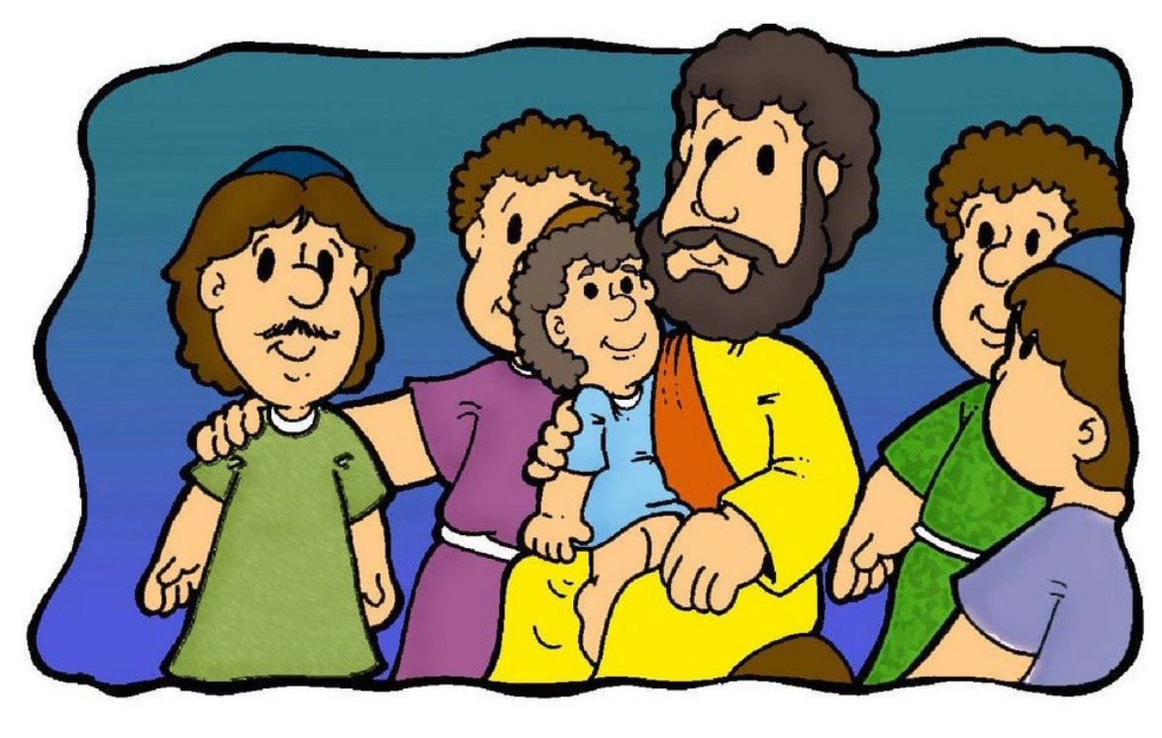



The Good Samaritan

Who is your neighbour? Write the names of people who you think are your neighbours in the circles around you.

Me

The Good Samaritan
Watch a video of the story: https://www.bbc.co.uk/bitesize/clips/zcyr87h

Read ²⁵ Then a teacher of the law stood up. He was trying to test Jesus. He said, “Teacher, what must I do to get life forever?”
²⁶ Jesus said to him, “What is written in the law? What do you read there?”
²⁷ The man answered, “Love the Lord your God. Love him with all your heart, all your soul, all your strength, and all your mind.” Also, “You must love your neighbour as you love yourself.”
²⁸ Jesus said to him, “Your answer is right. Do this and you will have life forever.”
²⁹ But the man wanted to show that the way he was living was right. So he said to Jesus, “And who is my neighbour?”
³⁰ To answer this question, Jesus said, “A man was going down the road from Jerusalem to Jericho. Some robbers attacked him. They tore off his clothes and beat him. Then they left him lying there, almost dead. ³¹ It happened that a Jewish priest was going down that road. When the priest saw the man, he walked by on the other side of the road. ³² Next, a Levite came there. He went over and looked at the man. Then he walked by on the other side of the road. ³³ Then a Samaritan travelling down the road came to where the hurt man was lying. He saw the man and felt very sorry for him. ³⁴ The Samaritan went to him and poured olive oil and wine on his wounds and bandaged them. He put the hurt man on his own donkey and took him to an inn. At the inn, the Samaritan took care of him. ³⁵ The next day, the Samaritan brought out two silver coins and gave them to the innkeeper. The Samaritan said, ‘Take care of this man. If you spend more money on him, I will pay it back to you when I come again.’”
³⁶ Then Jesus said, “Which one of these three men do you think was a neighbour to the man who was attacked by the robbers?”
³⁷ The teacher of the law answered, “The one who helped him.”
Jesus said to him, “Then go and do the same thing he did!”
Luke 10: 25-37

What is happening in the pictures below? How do the people feel?

Look at the goodies and baddies. Who would you expect to be the helper in the situations above?

Look the pictures below. Who are the goodies? Who are the baddies?




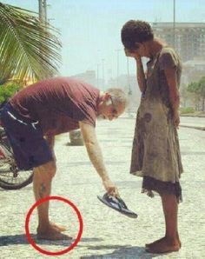

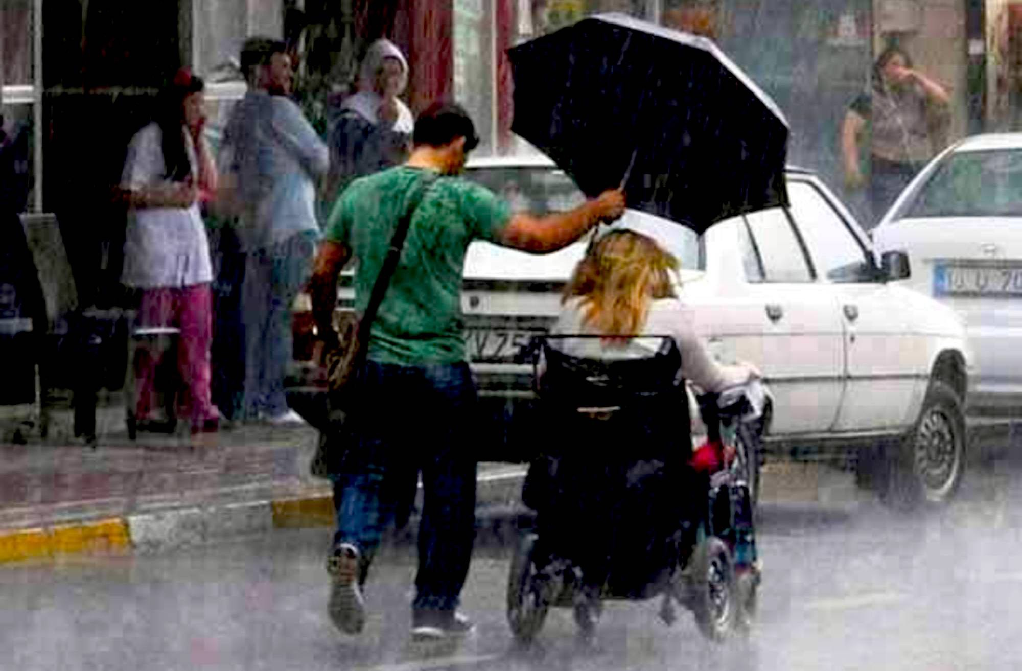

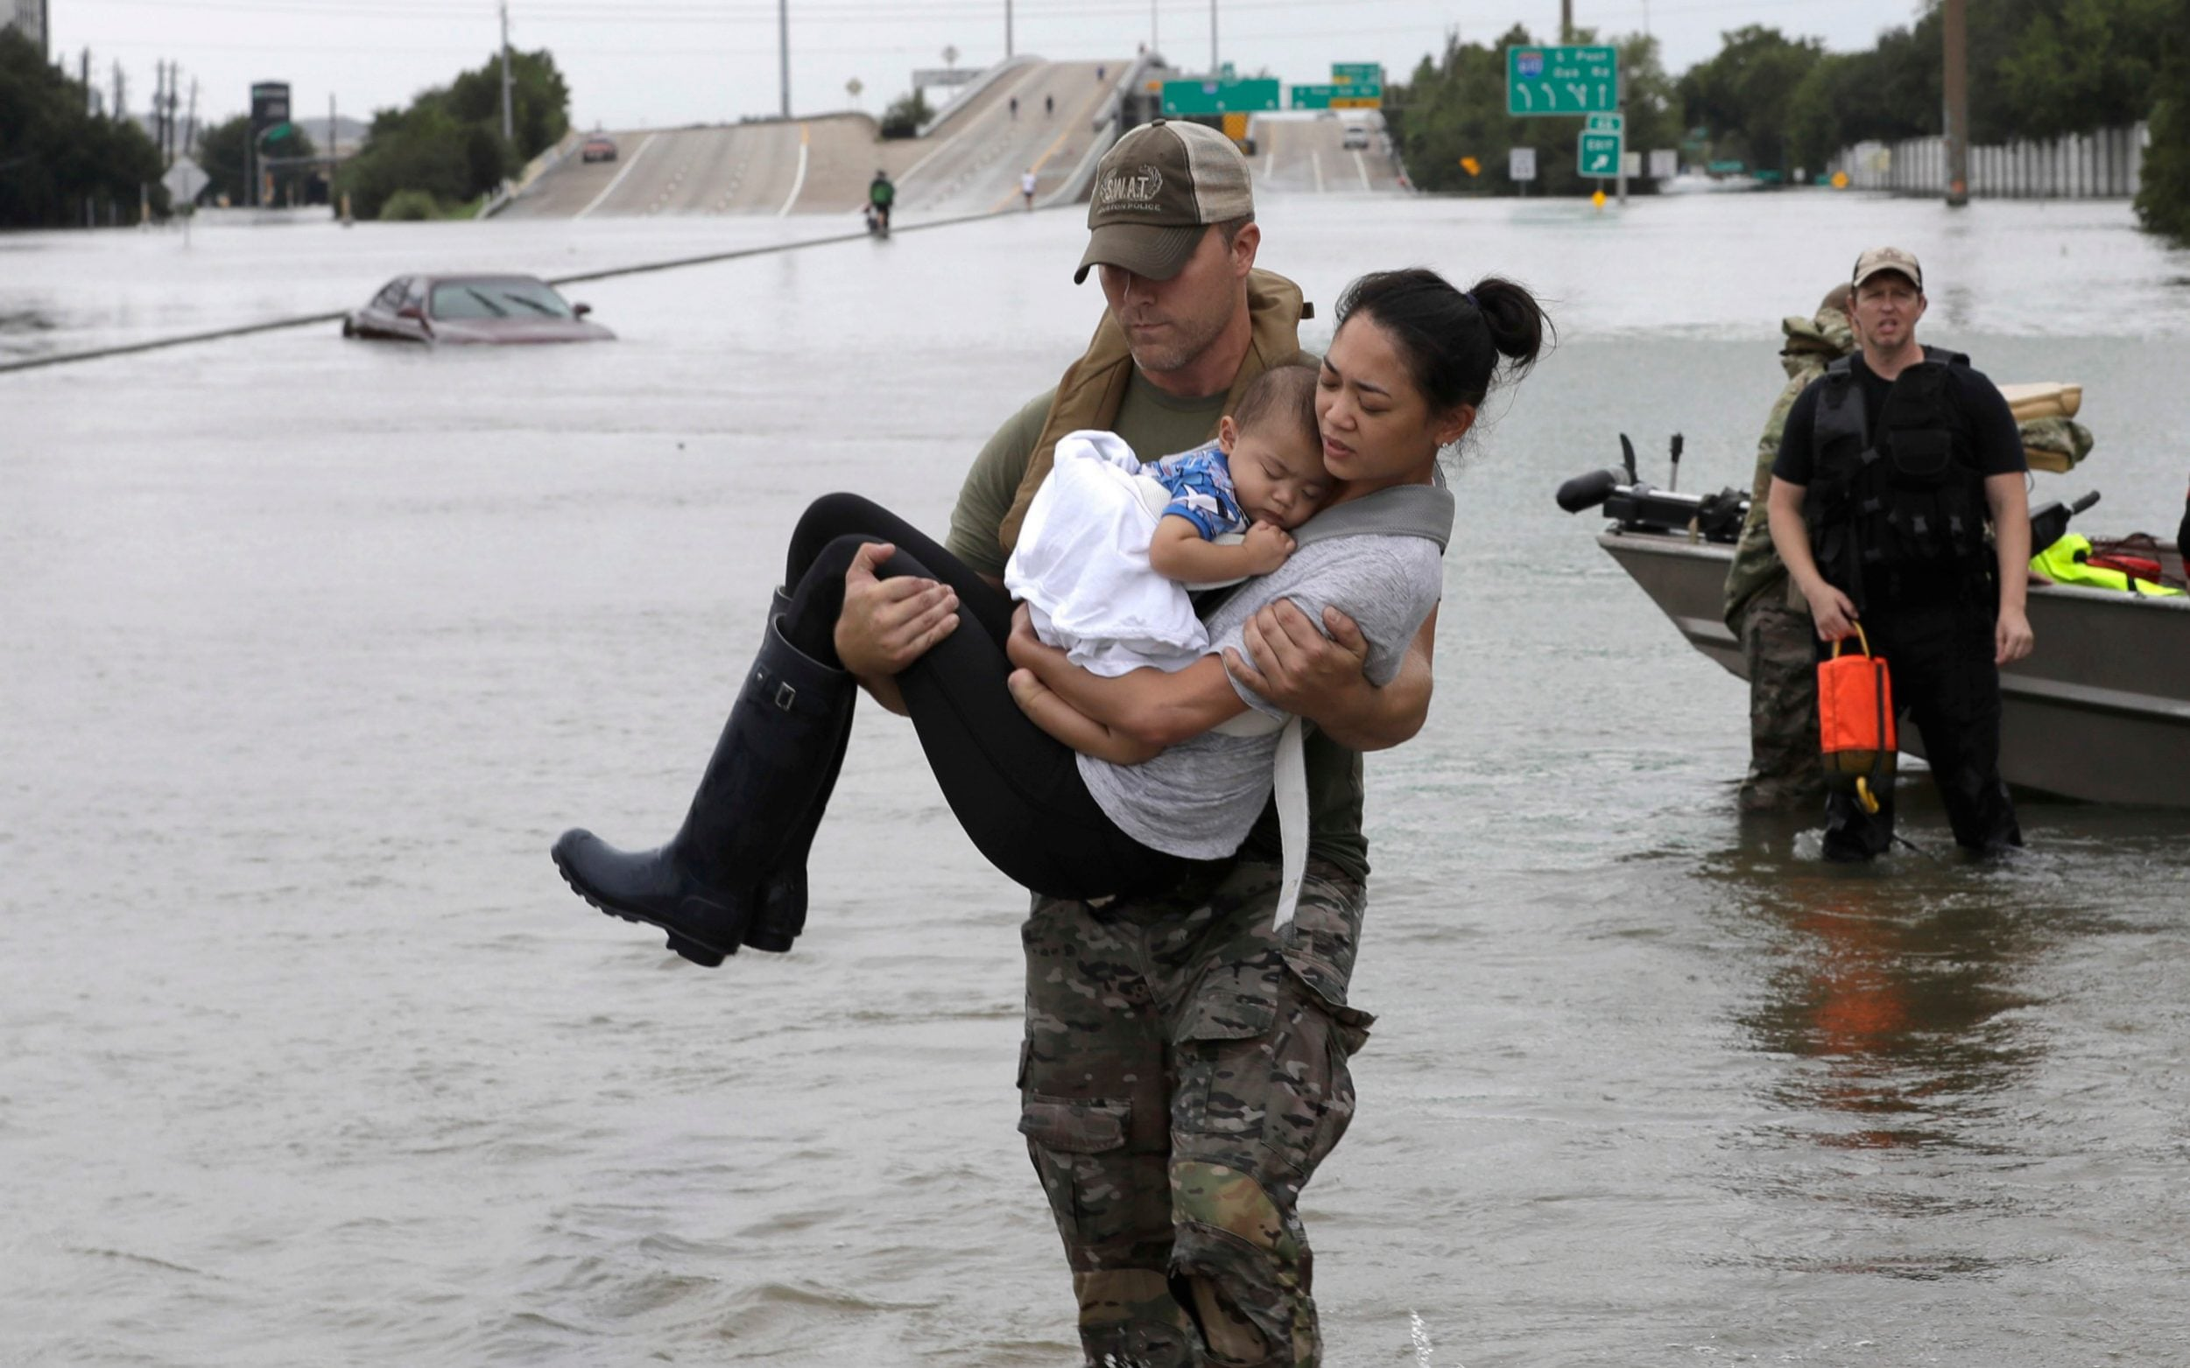

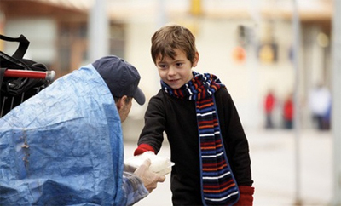

Christians believe that charitable work is one way of loving your neighbour. Look at the following website:
https://www.toilettwinning.org/


What does this charity do?


Who does the charity help?

What could you do to help your neighbours or make a difference in their lives?
Write or draw your ideas


