
Parables What stories did Jesus tell?

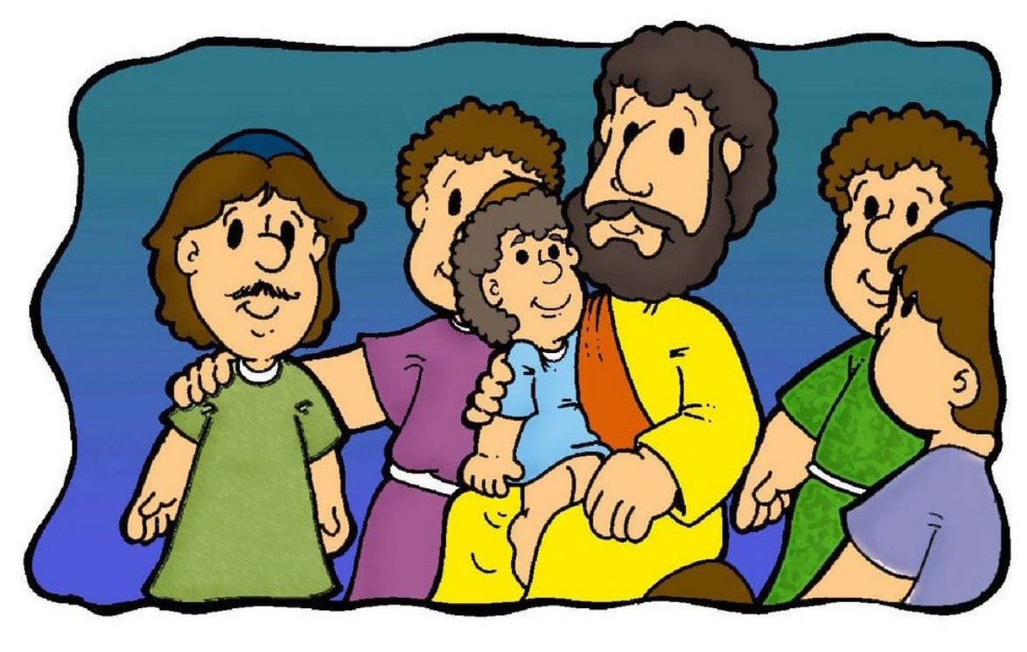
Build houses out of some different things in your house. E.g. Lego, old boxes, playdough, tins
  - Which was house was the strongest?
  - Can you tell someone why?

Tell the story to somebody at home. Make up names for the builders.

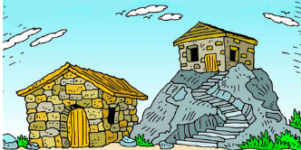
Watch a video of the story https://www.youtube.com/watch?v=CXWHLB1f6_U
The Parable of the Two Builders

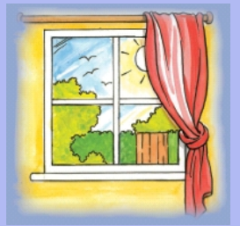
Read ²⁴ “Everyone who hears these things I say and obeys them is like a wise man. The wise man built his house on rock. ²⁵ It rained hard and the water rose. The winds blew and hit that house. But the house did not fall, because the house was built on rock. ²⁶ But the person who hears the things I teach and does not obey them is like a foolish man. The foolish man built his house on sand. ²⁷ It rained hard, the water rose, and the winds blew and hit that house. And the house fell with a big crash.”
Matthew 7 24:27



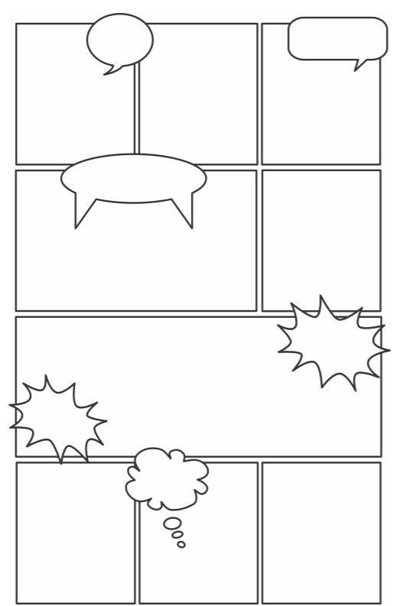

Create a comic strip to retell the story.
Use speech and thought bubbles to show how the builders felt.

Christians follow Jesus’ teachings to show them how to live. These are the firm foundations. They try to show these values in their lives:
Love, kindness, compassion, forgiveness, endurance
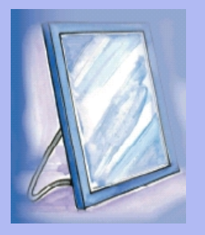

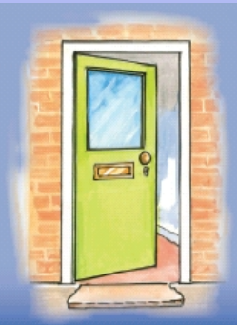

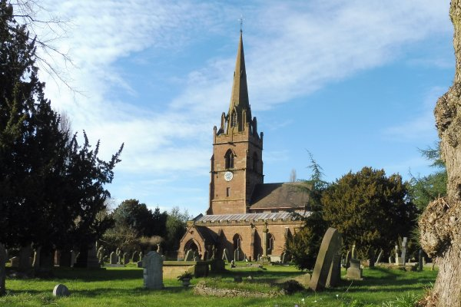
Find out about some of the things local churches do in the community. Write down your findings in the box below.

CHALLENGE: Make a poster for a local church which shows how they ‘live out’ the teachings of Jesus.

Think about the school values/Christian values.
Create a recipe for the best way to live:
A dash of
A tablespoon of
A cup of
A splash of

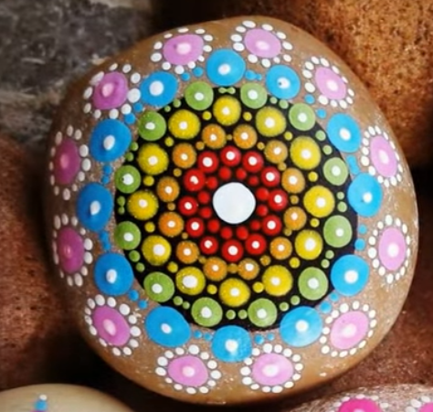

Create a Mandala Stone https://www.youtube.com/watch?v=UNnvvDQ0GFE
The initial black circle can represent your life.
The white dot in the centre can represent the thing / person that is at the centre of your life (e.g. .faith, education, love, family).
Each colour after that can represent the things that are our strong foundations (e.g. blue = family, green = honesty, yellow = laughter, pink = kindness…)

