Home Learning Pack


Exploring Easter Why do Christians celebrate Easter?

Content:
Easter Fact Sheet

Exploring Easter with EYFS

Primary Easter:
Palm Sunday
Jesus is Anointed
The Last Supper
Good Friday
Easter Sunday

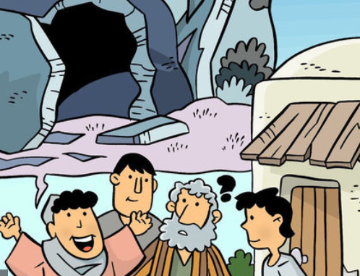

Easter Fact Sheet
Easter is the most important festival for many Christians. It is a time when the death and resurrection of Jesus are remembered, alongside the events leading up to them (Holy Week). Christians believe that Jesus died on a cross just outside the city of Jerusalem at the hands of the Romans. He was buried immediately, but then three days later a group of women discovered that his tomb was empty and after that many people claimed to have seen him, alive. Christians believe that Jesus’ death and resurrection were part of God’s plan, to bring peace between God and the people of earth.
Holy Week and Easter - Key Events Time Line
Palm Sunday | Jesus is Anointed | The Last Supper | Good Friday | Easter Sunday
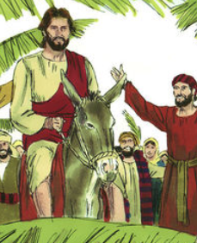 | 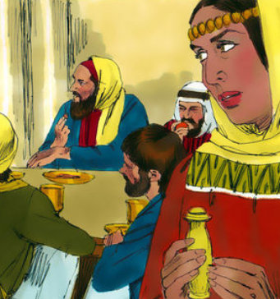 | 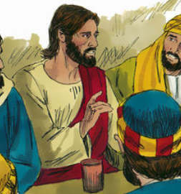 | 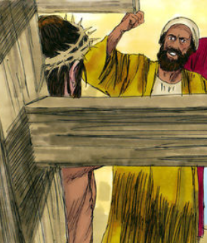 | 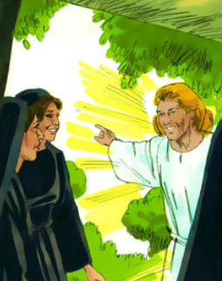

Palm Sunday
Holy Week begins with Jesus entering Jerusalem like a king – on a donkey, surrounded by people shouting his name excitedly and waving palm branches.

The Last Supper (Maundy Thursday)
It was the time of the Jewish Passover – the festival which remembers Moses leading the Israelites out of Egypt. After a week visiting friends around Jerusalem, Jesus wanted to share a special meal with his disciples. Christians remember this ‘last supper’ at communion or mass in church.

Good Friday - Jesus’ arrest and crucified
After the meal, Jesus went to pray in a quiet place – a garden called Gethsemane. It was in the garden that he was arrested and by Friday morning, he had been sentenced to death. Good Friday is the day when Christians remember Jesus dying on the cross.

Easter Sunday
On Easter Sunday, the women visited Jesus’ tomb but found the stone covering the cave had been moved and Jesus’ body was gone. Christians believe that Jesus had died but that he rose to life again – a sign that Jesus was truly God and more powerful than death.
Jesus dies on the Cross
Windows (Text) – explore the text in different ways

Watch: The Resurrection clip https://request.org.uk/restart/2017/03/14/holy-week-and-easter/
Read: Matthew 28:1-10
28 The day after the Sabbath day was the first day of the week. At dawn on the first day, Mary Magdalene and another woman named Mary went to look at the tomb.

2 At that time there was a strong earthquake. An angel of the Lord came down from heaven. The angel went to the tomb and rolled the stone away from the entrance. Then he sat on the stone. 3 He was shining as bright as lightning. His clothes were white as snow. 4 The soldiers guarding the tomb were very frightened of the angel. They shook with fear and then became like dead men.

5 The angel said to the women, “Don’t be afraid. I know that you are looking for Jesus, the one who was killed on the cross. 6 But he is not here. He has risen from death as he said he would. Come and see the place where his body was. 7 And go quickly and tell his followers. Say to them: ‘Jesus has risen from death. He is going into Galilee. He will be there before you. You will see him there.’” Then the angel said, “Now I have told you.”

8 The women left the tomb quickly. They were afraid, but they were also very happy. They ran to tell Jesus’ followers what had happened. 9 Suddenly, Jesus met them and said, “Greetings.” The women came up to Jesus, took hold of his feet, and worshiped him. 10 Then Jesus said to them, “Don’t be afraid. Go and tell my brothers to go on to Galilee. They will see me there.”

Think about the story
When they watched Jesus die on the cross his friends and family had lost all hope but on the first Easter day things are very different.

Listen to: Who is this man?
https://www.youtube.com/watch?v=7pQ1Wn0yP5g
This is a worship song that explains who Christians believe who Jesus is.

Challenge – Create a picture to illustrate one part of the song.
The Resurrection
Windows (Text) – explore the text in different ways

After reading to the story of Easter Sunday – think carefully about how the women were feeling at different times in the story and then fill in the table.
When do you think the women felt…
(Draw or write your answers)









The Resurrection is the most important event in the entire Bible for Christians and is sung about in worship songs all year round. It is because of what happened on Easter Sunday that Christians believe God has promised a way to heaven
Reflect on the importance of Easter Sunday for Christians as you complete the following activity.
The Resurrection

Mirrors (Impact) – reflect on what this means for the believers

Design a poster to advertise an Easter service for a church near to you.
Think about the wording and what might happen at the church. With an adult’s help look for ideas on the internet
Hold an Easter egg hunt. If you do not have enough chocolate eggs then cut out eggs from paper and decorate them.
Ask an adult to hide them for you.
As you look for the eggs think of the women going to the tomb to look for Jesus’ body.
Easter is a time to celebrate amazing surprises.
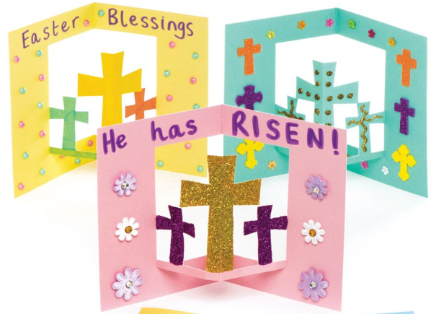
Design a card that explains what Christians believe about Easter. Make it bright and happy.
To finish and to see how much you remember play along with some Easter games
https://request.org.uk/restart/2016/02/03/the-easter-story-pairs-game/
https://request.org.uk/restart/2017/02/03/easter-story-drag-and-drop-game/
Easter is all about hope and new life. On the Easter egg write or draw your hopes for yourself, your family and the world.



The Resurrection
Door (Connection) - how could this impact how we think and act?

