Home Learning Pack


Exploring Easter Why do Christians celebrate Easter?

Content:
Easter Fact Sheet

Exploring Easter with EYFS

Primary Easter:
Palm Sunday
Jesus is Anointed
The Last Supper
Good Friday
Easter Sunday

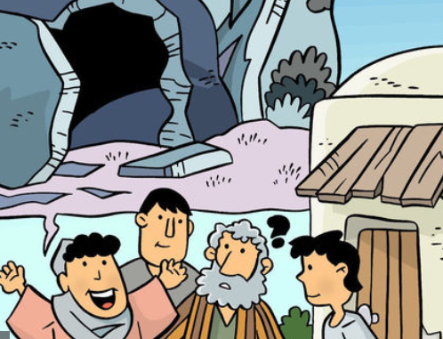

Easter Fact Sheet
Easter is the most important festival for many Christians. It is a time when the death and resurrection of Jesus are remembered, alongside the events leading up to them (Holy Week). Christians believe that Jesus died on a cross just outside the city of Jerusalem at the hands of the Romans. He was buried immediately, but then three days later a group of women discovered that his tomb was empty and after that many people claimed to have seen him, alive. Christians believe that Jesus’ death and resurrection were part of God’s plan, to bring peace between God and the people of earth.
Holy Week and Easter - Key Events Time Line
Palm Sunday | Jesus is Anointed | The Last Supper | Good Friday | Easter Sunday
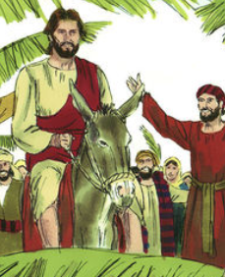 | 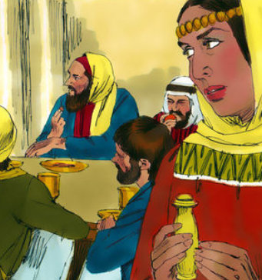 | 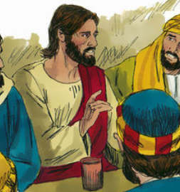 | 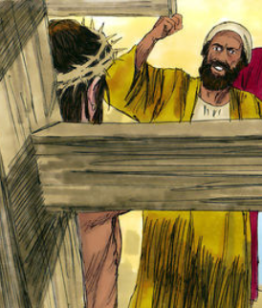 | 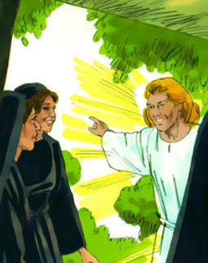

Palm Sunday
Holy Week begins with Jesus entering Jerusalem like a king – on a donkey, surrounded by people shouting his name excitedly and waving palm branches.

The Last Supper (Maundy Thursday)
It was the time of the Jewish Passover – the festival which remembers Moses leading the Israelites out of Egypt. After a week visiting friends around Jerusalem, Jesus wanted to share a special meal with his disciples. Christians remember this ‘last supper’ at communion or mass in church.

Good Friday - Jesus’ arrest and crucified
After the meal, Jesus went to pray in a quiet place – a garden called Gethsemane. It was in the garden that he was arrested and by Friday morning, he had been sentenced to death. Good Friday is the day when Christians remember Jesus dying on the cross.

Easter Sunday
On Easter Sunday, the women visited Jesus’ tomb but found the stone covering the cave had been moved and Jesus’ body was gone. Christians believe that Jesus had died but that he rose to life again – a sign that Jesus was truly God and more powerful than death.
Watch: The film clip, ‘Series Two - The Arrest to Easter Sunday’
https://request.org.uk/restart/2017/06/05/bible-quest-holy-week/
Read the story:
Very early in the morning, the soldiers brought Jesus to Pilate, the governor at the time. Pilate asked Jesus, "Are you the king of the Jews?"

Jesus replied, "Yes, I am."

This upset the chief priests because they were jealous of him and the Jewish friends He had made.

Pilate listened to the complaints of the people that brought Jesus, but he couldn't find any reason to punish Him. Pilate questioned Jesus, but Jesus didn't stick up for himself (He knew that they wouldn't listen anyway). He had done nothing wrong.

Pilate called together the chief priests, the rulers, and the people. He said to them, "I have talked to Jesus, and I find no reason to kill Him."

After they heard that, all the people shouted, "We want Jesus! Release Barabbas instead!" Barabbas had been in jail because he had killed someone, and the people wanted him to be free, and Jesus to be punished. (It sounds strange but it was like peer pressure. The chief priests went around telling people lies about Jesus, so that they would be afraid of Him, and would want to kill Him).

Pilate didn't like this one bit. He wanted to let Jesus go, so he tried to talk to the people but they didn't let him. They just kept shouting, "Crucify Him! Crucify Him!"

Pilate tried again, yelling, "What has Jesus done wrong? I can punish Him but then I must let Him go, He doesn't deserve to die!" But the people just shouted louder to crucify Jesus and Pilate wanted to please the crowd so he freed Barabbas and sent Jesus to die.

Next, the soldiers led Jesus toward a hill called Golgotha. They made Him carry the cross on His back, but becauseJesus couldn't carry it the whole way, He fell down. The soldiers had whipped His back and it hurt so much that Jesus couldn't handle the weight of the cross on His shoulders.

A man named Simon happened to be near Jesus when He fell, and the soldiers grabbed him, and made him carry the cross the rest of the way. The soldiers offered Jesus wine mixed with myrrh. This was supposed to help make it less painful, but Jesus refused to have any.
Jesus dies on the Cross
Windows (Text) – explore the text in different ways

When they reached the top of the hill, they nailed Jesus to the cross. There were three crosses: Jesus was in the middle, there was a criminal on His right, and on His left. Pilate made a sign to be put on the cross. It read what He was being punished for: Jesus of Nazareth, King of the Jews.

The soldiers watched Jesus and made fun of Him; they even divided up His clothes to be even meaner. Some people walked by and shouted, "You saved others, why can't you save yourself?" Jesus could have saved himself, but he chose not to. He wanted to save us instead.

Later, Jesus cried out, "It is finished." That is when Jesus bowed His head and died.

Suddenly, a huge curtain that hung at the temple was torn in half, from top to bottom. And a man that had wanted Jesus to die saw all of this and he said, "Surely this man was the Son of God!" He knew that he had been wrong about Jesus.

Think about the story
This was probably the saddest day ever for Jesus’ family and friends. Everything they had hoped for seemed to have gone wrong. Things just didn’t seem to turn out how they should have done. Some people call the day that Jesus died ‘Good Friday.’ It may seem a strange name for such a sad day.

Can you think of why this name may be used?

It is thought that originally the name Good Friday was used because at one time ‘good’ had the same meaning as the word ‘holy’ and was linked with God. Something that is ’holy’ is special and set aside for God.

Christians use crosses as necklaces, in churches and in their homes to remember what happened on ‘Good Friday.’
Look at the cross – what can you see?
Can you see the disciples at a table?
Can you see the cup and the bread from the last supper?
Can you see Jesus’ mother, Mary, standing at the foot of the cross?

Challenge – design a cross that includes all the stories that you have looked at from Holy Week
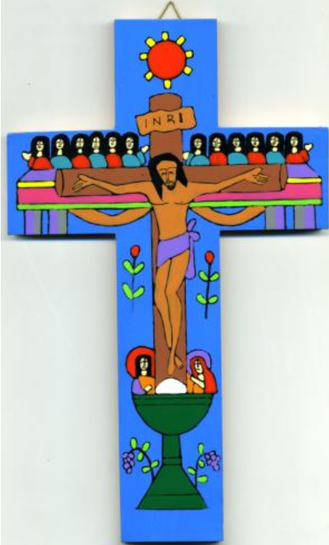
The story of ‘Good Friday’ is one of the most important stories for Christians and is often remembered every year as part of the Easter celebrations. It is because of what happened on Good Friday and Easter Sunday that Christians believe that people and God can be friends again.
Reflect on the importance of Easter for Christians as you complete the following activity.

Jesus Dies on the Cross

Mirrors (Impact) – reflect on what this means for the believers

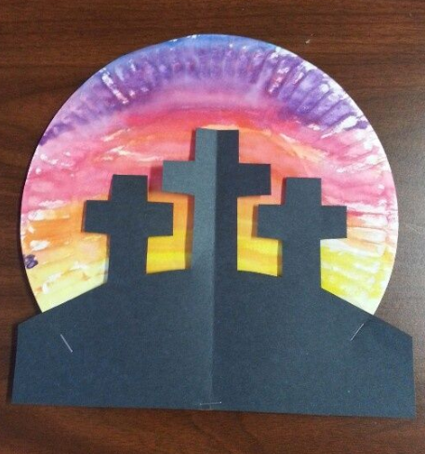
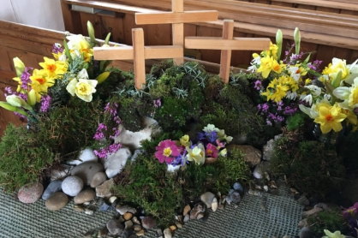
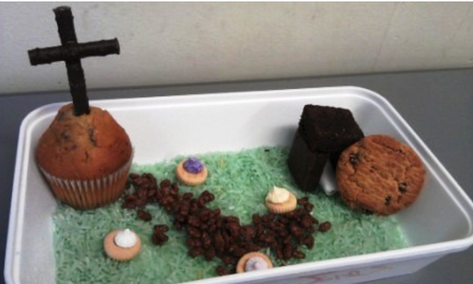
Christians will often make Easter Gardens to remember what happened at the first Easter. Watch the film to find out more:
https://request.org.uk/restart/2017/02/23/make-an-easter-garden/
Choose one of the following gardens to copy and make or design your own:

I am sorry …
Christians believe that because Jesus died on the cross, they can freely ask God for forgiveness - they can say sorry and know they are forgiven. We all do and say things wrong, things that we regret and wish we hadn’t. What have you done or said wrong?

If you want to, using a pencil, write a sorry prayer in the speech bubble - then rub it out as a symbol of God’s forgiveness.

Is there anyone who you need to say sorry to?


Simon, a Cyrenian, helped Jesus to carry his cross towards Golgotha. There are lots of people in our lives that we can provide a ‘helping hand’ to in the same way that Simon helped Jesus. Who could you help, with an action, a letter, or kind words maybe? It might be something really small, but it might make a big difference. If you want to, you can write or draw a picture of the person on a hand shape.
Jesus Dies on the Cross
Door (Connection) - how could this impact how we think and act?

