Home Learning Pack


Exploring Easter Why do Christians celebrate Easter?

Content:
Easter Fact Sheet

Exploring Easter with EYFS

Primary Easter:
Palm Sunday
Jesus is Anointed
The Last Supper
Good Friday
Easter Sunday

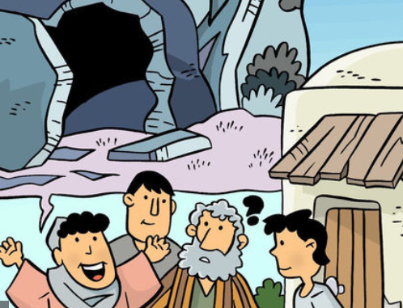

Easter Fact Sheet
Easter is the most important festival for many Christians. It is a time when the death and resurrection of Jesus are remembered, alongside the events leading up to them (Holy Week). Christians believe that Jesus died on a cross just outside the city of Jerusalem at the hands of the Romans. He was buried immediately, but then three days later a group of women discovered that his tomb was empty and after that many people claimed to have seen him, alive. Christians believe that Jesus’ death and resurrection were part of God’s plan, to bring peace between God and the people of earth.
Holy Week and Easter - Key Events Time Line
Palm Sunday | Jesus is Anointed | The Last Supper | Good Friday | Easter Sunday
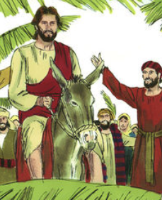 | 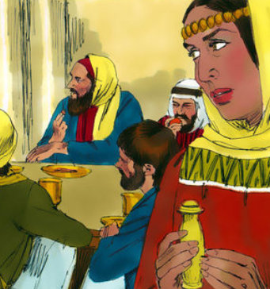 | 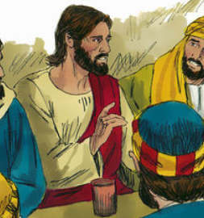 | 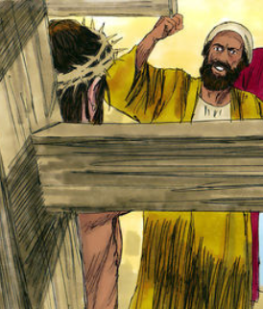 | 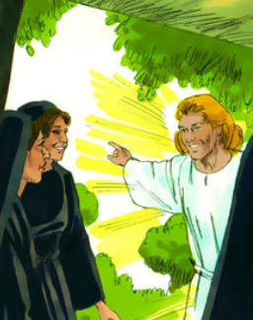

Palm Sunday
Holy Week begins with Jesus entering Jerusalem like a king – on a donkey, surrounded by people shouting his name excitedly and waving palm branches.

The Last Supper (Maundy Thursday)
It was the time of the Jewish Passover – the festival which remembers Moses leading the Israelites out of Egypt. After a week visiting friends around Jerusalem, Jesus wanted to share a special meal with his disciples. Christians remember this ‘last supper’ at communion or mass in church.

Good Friday - Jesus’ arrest and crucified
After the meal, Jesus went to pray in a quiet place – a garden called Gethsemane. It was in the garden that he was arrested and by Friday morning, he had been sentenced to death. Good Friday is the day when Christians remember Jesus dying on the cross.

Easter Sunday
On Easter Sunday, the women visited Jesus’ tomb but found the stone covering the cave had been moved and Jesus’ body was gone. Christians believe that Jesus had died but that he rose to life again – a sign that Jesus was truly God and more powerful than death.
Jesus is Anointed
Windows (Text) – explore the text in different ways

Watch: The Last Supper and Arrest https://request.org.uk/restart/2017/03/14/holy-week-and-easter/
Read: Mark 14:12-2612
It was now the first day of the Feast of Unleavened Bread. This was a time when the Jews always sacrificed the Passover lambs. Jesus’ followers came to him. They said, “We will go and prepare everything for the Passover Feast. Where do you want to eat the feast?”
13 Jesus sent two of his followers and said to them, “Go into the city. A man carrying a jar of water will meet you. Follow him. 14 He will go into a house. Tell the owner of the house, ‘The Teacher asks that you show us the room where he and his followers can eat the Passover Feast.’ 15 The owner will show you a large room upstairs. This room is ready. Prepare the food for us there.”
16 So the followers left and went into the city. Everything happened as Jesus had said. So they prepared the Passover Feast.
17 In the evening, Jesus went to that house with the twelve. 18 While they were all eating, Jesus said, “I tell you the truth. One of you will give me to my enemies—one of you eating with me now.”
19 The followers were very sad to hear this. Each one said to Jesus, “I am not the one, am I?”
20 Jesus answered, “The man who is against me is one of the twelve. He is the one who dips his bread into the bowl with me. 21 The Son of Man must go and die. The Scriptures say this will happen. How terrible it will be for the person who gives the Son of Man to be killed. It would be better for that person if he had never been born.”

22 While they were eating, Jesus took some bread. He thanked God for it and broke it. Then he gave it to his followers and said, “Take it. This bread is my body.”
23 Then Jesus took a cup. He thanked God for it and gave it to the followers. All the followers drank from the cup. 24 Then Jesus said, “This is my blood which begins the new[a] agreement that God makes with his people. This blood is poured out for many. 25 I tell you the truth. I will not drink of this fruit of the vine[b] again until that day when I drink it new in the kingdom of God.” 26 They sang a hymn and went out to the Mount of Olives.
The Last Supper
Windows (Text) – explore the text in different ways

Think about the story:
Jesus and his disciples were in Jerusalem to celebrate the Jewish festival of the Passover. This is a time of the year when the Jewish people remember the story of Moses and how God set the people free from slavery in Egypt. It was an exciting time for the Jews and as part of the celebration they would have a big meal. It was at this meal when Jesus’ last supper with his disciples takes place.

As part of the Passover celebrations the Jews use a Seder plate – this helps to tell the story of the fist Passover and the escape from Egypt.
A Seder plate holds symbols of the Pesach story. Karpas — a green vegetable, often parsley — is dipped in salt water to remind us of the tears of the enslaved Israelites. A sweet fruit paste called charoset (from the Hebrew word cheres, “clay”) is like the mortar that the Israelites used to construct buildings for the Egyptian empire. Maror, a bitter herb (usually horseradish), recalls the bitterness of slavery. It is sometimes joined by hazeret, a second bitter herb. A roasted lamb shank bone, zeroah, is a reminder of the offering the Jews made before leaving Egypt. (Vegetarian families will sometimes use a beet instead). Lastly, the beitzah — a roasted or hard-boiled egg — stands for the offering made on every holiday in the days when the Temple stood. That’s one powerful centrepiece!

Get creative – make your own Seder Plate. They are often very decorative.

Find out more about the Passover meal and the way that the Jews still celebrate it today:
https://www.bbc.co.uk/bitesize/clips/z3n34wx
The ‘Last Supper’ is an important story for Christians and is often remembered as part of the Holy Week celebrations. It is because of what happened at the Last Supper that Christians celebrate the Eucharist (sometimes called communion or the Lord’s Supper) today. https://request.org.uk/restart/2015/09/18/communion-a-special-meal-2/
As you complete the following activities reflect on how you think the disciples would have felt as they ate the meal with Jesus. It was meant to be a time to celebrate what had happened at the time of Moses but it became a signpost pointing to what was going to happen to Jesus.

The Last Supper

Mirrors (Impact) – reflect on what this means for the believers

Find out more about how Christians from different churches still celebrate the Eucharist today.
https://request.org.uk/life/spirituality/communion/
Write a prayer that a Christian could use as part of a Eucharist service in church. You may want to split it into sections:
1) Thank You – think about the things you want to say thank you for
2) Sorry – think about the things that are not right in the world
3) Please - think about the things you and other people really need at this time
Write a message from one of the disciples back home explaining what has just happened at the Passover Meal.
Challenge – can you describe how people are feeling at the beginning of the meal, once Jesus starts to talk and at the end of the meal?
Why does the mood change?

The Last Supper
Door (Connection) - how could this impact how we think and act?

Get baking – with an adult try to make the type of bread Jesus and his disciples would have eaten at the last supper.
Ingredients
200g/7oz plain or wholemeal flour
¼ tsp salt
100ml/3½fl oz warm water
2 tbsp oil (olive, sunflower or vegetable), plus extra for cooking

- Mix the flour, salt and water together and add the oil
- Knead the dough for 5 minutes and then divide it into 6 small balls
- On a clean surface put some flour down and then roll the dough balls out into flat bread
- With an adult heat a small amount of oil in a frying pan. Put the flatbread into the pan; cook it for two minutes on each side.
https://www.bbc.co.uk/food/recipes/quick_flatbreads_43123

The Passover and the Eucharist Meal are all about remembering and also saying thank you for those things you are remembering.

Create a memory box of things you want to say thank you for.
A memory box is something where we can put things that help us to remember special things and people. You can put anything your like into the box – photographs, drawings, letters, tickets, poems, stones – you can put anything that helps you to remember why these things are special to you. You may also want to write a thank you note or prayer for the person or thing you are remembering. The memory box is a special thing so try to decorate it in a special way.

