Home Learning Pack


Exploring Easter Why do Christians celebrate Easter?

Content:
Easter Fact Sheet

Exploring Easter with EYFS

Primary Easter:
Palm Sunday
Jesus is Anointed
The Last Supper
Good Friday
Easter Sunday

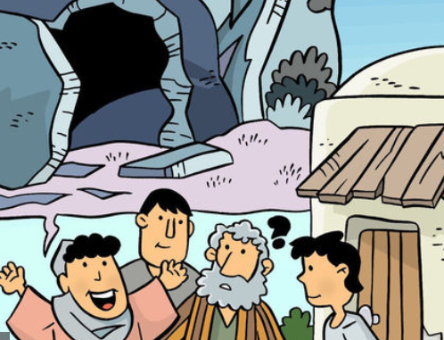

Easter Fact Sheet
Easter is the most important festival for many Christians. It is a time when the death and resurrection of Jesus are remembered, alongside the events leading up to them (Holy Week). Christians believe that Jesus died on a cross just outside the city of Jerusalem at the hands of the Romans. He was buried immediately, but then three days later a group of women discovered that his tomb was empty and after that many people claimed to have seen him, alive. Christians believe that Jesus’ death and resurrection were part of God’s plan, to bring peace between God and the people of earth.
Holy Week and Easter - Key Events Time Line
Palm Sunday | Jesus is Anointed | The Last Supper | Good Friday | Easter Sunday
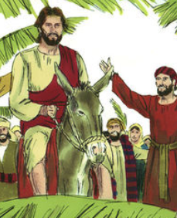 | 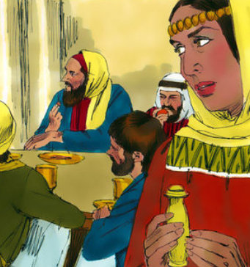 | 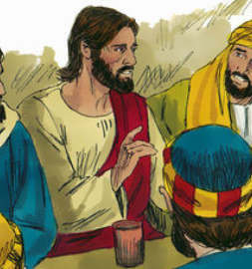 | 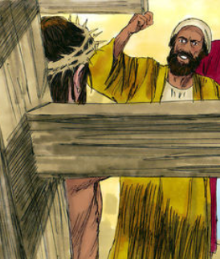 | 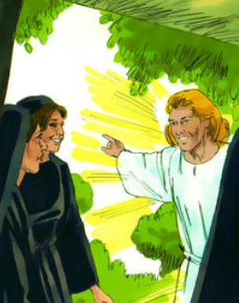

Palm Sunday
Holy Week begins with Jesus entering Jerusalem like a king – on a donkey, surrounded by people shouting his name excitedly and waving palm branches.

The Last Supper (Maundy Thursday)
It was the time of the Jewish Passover – the festival which remembers Moses leading the Israelites out of Egypt. After a week visiting friends around Jerusalem, Jesus wanted to share a special meal with his disciples. Christians remember this ‘last supper’ at communion or mass in church.

Good Friday - Jesus’ arrest and crucified
After the meal, Jesus went to pray in a quiet place – a garden called Gethsemane. It was in the garden that he was arrested and by Friday morning, he had been sentenced to death. Good Friday is the day when Christians remember Jesus dying on the cross.

Easter Sunday
On Easter Sunday, the women visited Jesus’ tomb but found the stone covering the cave had been moved and Jesus’ body was gone. Christians believe that Jesus had died but that he rose to life again – a sign that Jesus was truly God and more powerful than death.
Watch: The Anointing film clip https://request.org.uk/restart/2017/03/14/holy-week-and-easter/
Read: The Bible Passage Mark 14:3-9
3 Jesus was in Bethany. He was at dinner in the house of Simon, who had a harmful skin disease. While Jesus was there, a woman came to him. She had an alabaster jar filled with very expensive perfume, made of pure nard. The woman opened the jar and poured the perfume on Jesus’ head.

4 Some of those who were there saw this and became angry. They complained to each other, saying, “Why waste that perfume? 5 It was worth a full year’s work. It could be sold, and the money could be given to the poor.” They spoke to the woman sharply.

6 Jesus said, “Don’t bother the woman. Why are you troubling her? She did a beautiful thing for me. 7 You will always have the poor with you. You can help them anytime you want. But you will not always have me. 8 This woman did the only thing she could do for me. She poured perfume on my body. She did this before I die to prepare me for burial. 9 I tell you the truth. The Good News will be told to people in all the world. And in every place it is preached, what this woman has done will be told. And people will remember her.”

Think about the story
Jesus spent a lot of time with lots of different people, going into their homes, eating with them and teaching them about God. It was tradition in Jesus’ time that the men and women would eat separately, that the women served the men before eating themselves. However meals with Jesus were very different. Jesus treated both men and women with respect. Jesus ate with both men and women and let the women listen to his teaching as well as the men.

How do you think this would make the women feel?
How might some of the men feel?

Jesus is Anointed
Windows (Text) – explore the text in different ways

In Jesus’ time it was also common for a guest to have their feet washed when they visited a house. This was a sign of respect. In this story the woman goes even further and pours perfume over Jesus’ head – we often call this anointing.
Why do you think she would do that?
In the Bible anointing is a sign of respect but it is also a sign that someone has been chosen to do a very special job. In this Bible passage Jesus points to the fact that his special job was to die – something that is remembered at Easter.
What do you think the people at the meal were thinking?
Write your ideas in the bubbles…
Jesus The Guests

The Woman

Challenge
Write a blog page of the meal from the view of different people - Simon, Jesus, a guest and the woman.

The ‘Anointing of Jesus’ is an important story for Christians and is often remembered as part of the Holy Week celebrations. It is a story that teaches about how God sees all people as important but it also shows how everything in Jesus’ life was pointing to the cross.
As you complete the following activities reflect on how Christians believe we should treat each other, following Jesus’ examples.

Research the work of the Christian charity, the Salvation Army. The charity believes that in showing love and respect to others they are showing love and respect to God.
Design a poster to show the history of the organisation and also some of the work that they do in the name of Jesus.
Draw a picture of a perfume jar. Write a prayer or reflection on it, taking time to think about all the people who are lonely, forgotten or ignored in the world. Decorate the jar to show how precious they are to God.
One way that Christians believe that they can show respect to God is by respecting and caring for his creation and that includes people. Look at the 40 Acts of Kindness website: https://40acts.org.uk/resources/
Download the family wall chart, try and complete one act of kindness each day between now and Easter.
Jesus is Anointed

Mirrors (Impact) – reflect on what this means for the believers

Imagine that Jesus or some other very important person is coming to have a meal at your house.
What special things are you going to organise?
How will you treat him when he arrives?
What food would you prepare?
Design an invitation for the meal, which other people will you invite?
Design a menu to show what food you would serve. If possible you may want to prepare the meal to share with your family or on paper plates draw the food you will eat at the meal.
Write a list of questions you would like to ask her.
Challenge: write a letter from Jesus to yourself thanking you for the meal and everything that you have done.

Jesus is Anointed
Door (Connection) - how could this impact how we think and act?

