Home Learning Pack


Exploring Easter Why do Christians celebrate Easter?

Content:
Easter Fact Sheet

Exploring Easter with EYFS

Primary Easter:
Palm Sunday
Jesus is Anointed
The Last Supper
Good Friday
Easter Sunday

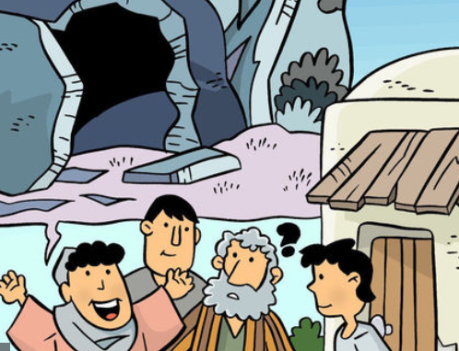

Easter Fact Sheet
Easter is the most important festival for many Christians. It is a time when the death and resurrection of Jesus are remembered, alongside the events leading up to them (Holy Week). Christians believe that Jesus died on a cross just outside the city of Jerusalem at the hands of the Romans. He was buried immediately, but then three days later a group of women discovered that his tomb was empty and after that many people claimed to have seen him, alive. Christians believe that Jesus’ death and resurrection were part of God’s plan, to bring peace between God and the people of earth.
Holy Week and Easter - Key Events Time Line
Palm Sunday | Jesus is Anointed | The Last Supper | Good Friday | Easter Sunday
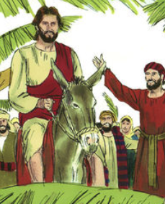 | 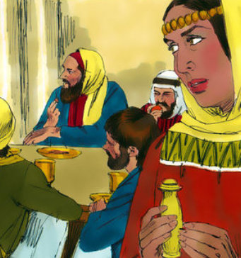 | 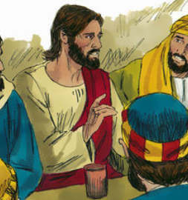 | 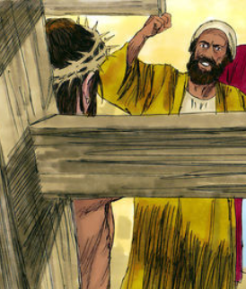 | 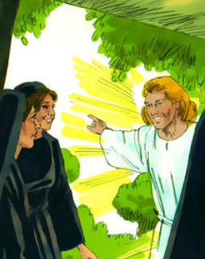

Palm Sunday
Holy Week begins with Jesus entering Jerusalem like a king – on a donkey, surrounded by people shouting his name excitedly and waving palm branches.

The Last Supper (Maundy Thursday)
It was the time of the Jewish Passover – the festival which remembers Moses leading the Israelites out of Egypt. After a week visiting friends around Jerusalem, Jesus wanted to share a special meal with his disciples. Christians remember this ‘last supper’ at communion or mass in church.

Good Friday - Jesus’ arrest and crucified
After the meal, Jesus went to pray in a quiet place – a garden called Gethsemane. It was in the garden that he was arrested and by Friday morning, he had been sentenced to death. Good Friday is the day when Christians remember Jesus dying on the cross.

Easter Sunday
On Easter Sunday, the women visited Jesus’ tomb but found the stone covering the cave had been moved and Jesus’ body was gone. Christians believe that Jesus had died but that he rose to life again – a sign that Jesus was truly God and more powerful than death.
Palm Sunday
Windows (Text) – explore the text in different ways


Watch: The Palm Sunday film clip https://request.org.uk/restart/2017/03/14/holy-week-and-easter/
Read: The Bible Passage Mark 11:1-11
11 Jesus and his followers were coming closer to Jerusalem. They came to the towns of Bethphage and Bethany near the Mount of Olives. There Jesus sent two of his followers. 2 He said to them, “Go to the town you see there. When you enter it, you will find a colt tied which no one has ever ridden. Untie it and bring it here to me. 3 If anyone asks you why you are doing this, tell him, ‘The Master needs the colt. He will send it back soon.’”

4 The followers went into the town. They found a colt tied in the street near the door of a house, and they untied it. 5 Some people were standing there and asked, “What are you doing? Why are you untying that colt?” 6 The followers answered the way Jesus told them to answer. And the people let them take the colt.

7 The followers brought the colt to Jesus. They put their coats on the colt, and Jesus sat on it. 8 Many people spread their coats on the road. Others cut branches in the fields and spread the branches on the road. 9 Some of the people were walking ahead of Jesus. Others were following him. All of them were shouting,

“Hosanna! Praise God!
God bless the One who comes in the name of the Lord!
10 God bless the kingdom of our father David!
That kingdom is coming!
Praise to God in heaven!”

11 Jesus entered Jerusalem and went into the Temple. When he had looked at everything, and since it was already late, he went out to Bethany with the 12 apostles.

Think about the story
Have you ever been to a celebration? Maybe you have been to a birthday, wedding or a street party. Was it noisy? Did people sing or cheer? Was there music? How did you feel to be part of it all?

Imagine that you are in the middle of the crowd when Jesus rides past. What do you think it would be like? What would you hear and see? How would you feel? What would you do?

Write or draw your ideas in the box below:

Challenge - Exploring Deeper
There is a lot of hidden meaning and clues in this story to help us to understand who Christians believe Jesus is and what he was like. Either complete the table by drawing a symbol that would help to explain the hidden meanings. Or use a separate piece of paper and create a poster with the symbols on.

Clue | Meaning | Symbol
Jesus riding on a colt | This was a sign of peace. When a king rode into a city on a colt or a donkey it showed that he was coming in peace.
Waving the palm branches | The palm branch represented goodness and victory.
King David | Jesus was born in Bethlehem – the city of King David because Mary and Joseph were descendants of David.
(Hosanna) Praise God | The word ‘Hosanna’ means ‘save now.’ The people saw Jesus as a king who would save them from all their troubles



Palm Sunday is an important day for Christians – it is a time when they remember Jesus entering Jerusalem as a king. It is also the day that celebrates the beginning of Holy Week – the week leading up to Easter.
Choose a couple of these activities to complete and reflect on what Christians believe about Palm Sunday.

Listen to ‘King of Me’ https://www.youtube.com/watch?v=ks6zl2hL2Uk – On Palm Sunday the people treated Jesus as King. This song is about how Christians believe God is the king of all things.
Challenge – write another verse for the song.
Make a no-bake rocky road - https://www.spendwithpennies.com/easy-rocky-road/ Decorate it with sprinkles to represent the words the people shouted. Can you remember what they were?
Create a Crown – decorate so that it is fit for a king. Write words on it that Christians would use to describe Jesus.
Create a Palm Leaf – using green paper, draw around your hand and cut it out. Write a prayer on the leaf that could be used in a church service on Palm Sunday.
Palm Sunday

Mirrors (Impact) – reflect on what this means for the believers

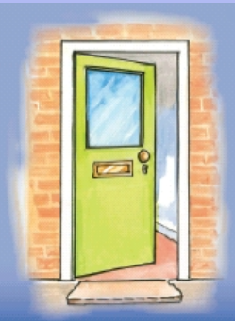

Imagine – if you were given the power to be king or queen for the next year what would you do? Think about the type of king that the Bible teaches Jesus was – someone who cared for people, who helped people, who made sure everyone had enough food and who helped his friends when they were scared.

Would you be like that?

Think about what kind of king or queen you think the world needs now.

What decisions would you make?
What rules would you make?
How would you treat people?
How would you behave?

Write (or record) a speech that tells the people all about what you will be like as a queen/king and what you want to see happen in the world.

Challenge
Write (and send if possible) a letter or email to someone you know who is a good leader. Perhaps you could say thank you for all that they do and suggests things that you would do in the future if you were them.

Palm Sunday
Door (Connection) - how could this impact how we think and act?

