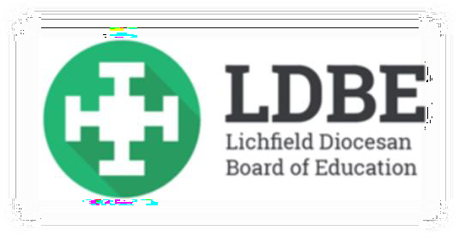
People of Faith
Who was Martin Luther King?

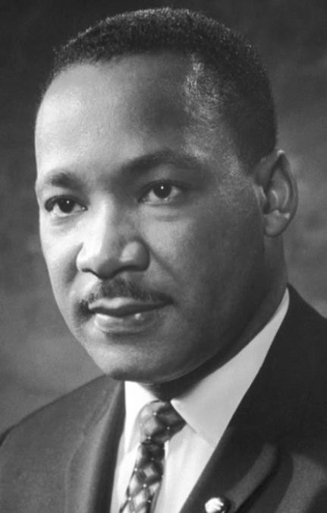

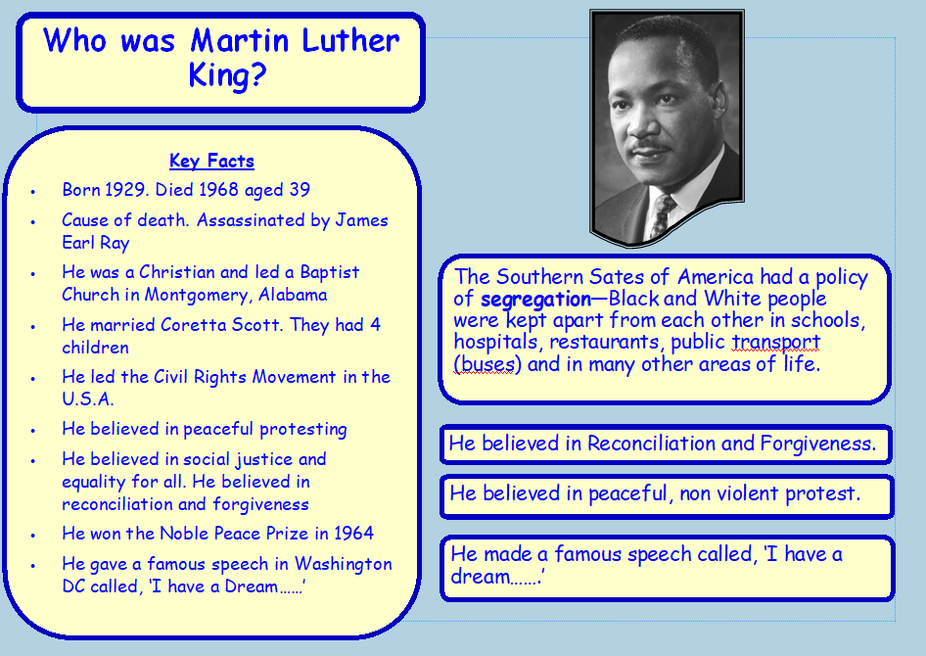

Background information
Martin Luther King was a black American who lived during extreme racial prejudice and discrimination in the Southern States of the U.S.A. He was a Christian and led a Baptist church. He believed the way in which black people were treated in the Southern States of America was wrong. Where Martin lived black people were segregated from white people in many areas of life. These included schools, hospitals, public toilets, restaurants and public transport like buses. At the time an organisation called the Klu Klux Klan (KKK) supported the belief that slavery should return. Of course not all white people believed this. Many supported Martin and his followers through a group called the Civil Rights Movement which Martin led. This movement organised peaceful protests against segregation, racism and inequality. They wanted justice in what they saw as an unjust situation for black people. A turning point for Martin and his followers was the ‘bus boycott’ started through the bravery of one woman, Rosa Parkes.Through many difficult times Martin and his followers made changes. Segregation was made illegal. However Martin paid the ultimate price by losing his life for what he believed. Soon after his famous, ‘I have a dream speech’ he was assassinated by James Earl Ray in 1968.



Window: Exploring the story of Martin Luther King
- Three ideas that were important to Martin were: Justice, Equality and Peaceful Protest. What do these words mean? Use a dictionary to help you.
- Find out the meaning of: Prejudice, Discrimination, Racism, Segregation and Slavery.
- Create a story board, poster or web page for someone who knows nothing about Martin Luther King and what he did. A useful website is: https://www.historyforkids.net/martin-luther-king.html
- Find out about the story Rosa Parkes. How do you think the words: brave, resilient, strength and fearless would fit into her story?

Challenge yourself
- Martin’s last speech was called, ‘I have a dream…’ Here is part of it.
“ I have a dream that my four little children will one day live in a country where they will not be judged by the colour of their skin but by who they are and their character.

I have a dream that one day…..little black boys and black girls will be able to join hands with little white boys and white girls and walk together as sisters and brothers. I have a dream today.”
You can listen to this speech on YouTube: https://www.youtube.com/watch?v=3vDWWy4CMhE
This was Martin’s vision for the future. What he hoped for.
What is your vision for the future? Is it for world where we all live in peace? Is it a world with no war? Is it for a world in which we take care of each other and the world in which we live?
Try and write your own ‘I have a dream…..’ speech as a vision for your

My own I have a dream speech..
I have a dream that one day………….
You could write your speech based on one or more of the following:
- For a world that is safe for everyone
- For the planet and its environment
- For a world where everyone respected each other
- For a world where there was no poverty or hunger
- Or you could just write your own vision for the future

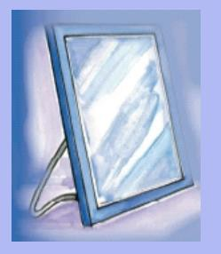

Mirrors: What does the story of Martin Luther King mean for Christians?

Martin was influenced by his Christian faith and the way in which his parents brought him up. His father was a Baptist minister (vicar). One teaching he was influenced by was:

- The Golden Rule, ‘Love your neighbour as yourself’ or ‘Treat others as you would like to be treated.’ This is part of the story of the ‘Good Samaritan’ found in the Gospel of Luke chapter 10 verses 25-37. Martin said that his parents taught him not to hate the white man, but that it was his duty as a Christian to love him. The story of the Good Samaritan is about how sworn enemies can put this to one side to help each other in times of need.

1. Find out about how Christians today help those around them. You could explore a Christian charity like: Christian Aid, Barnardo’s or the Salvation Army. Find out from their websites what they do and how they help those in need.

Challenge yourself
1. Create a project booklet based on your charity. Write about what they do and how they help others. Include pictures and images if you can. You could do this on your computer if you have one.
Charities you could explore: Christian Aid
CAFOD
Salvation Army World Vision

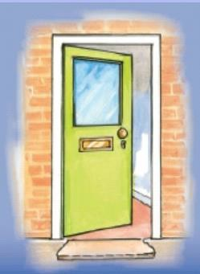
Door – What have I learnt from the story of Martin Luther King? What could I do?
- Think of acts of kindness you could do at home to help your parents or carers that illustrates ‘Treat others as you would like to be treated.’ Think of at least one act of kindness you could do each day. Keep a diary of what you do, or create an act of kindness tree. The leaves you decorate your tree with could have on them the acts of kindness you have done.
- Draw up a list of acts of kindness that people could do for their neighbours and friends. Think particularly about the elderly or those that have no one to help them.
- Create an ‘acts of kindness’ book and checklist. You could add drawings or pictures to illustrate your ideas.

Challenge yourself
1. Martin Luther King wanted justice and equality for all. Remind yourself about what these words mean. Now look in newspapers and magazines and find out examples of injustice and inequality. What ideas do you have to challenge these?

Clue
Think about what children around the world have been doing to challenge global warming and climate change. Gretta Thunberg.

