
People of Faith
Who was Bernadette of Lourdes?

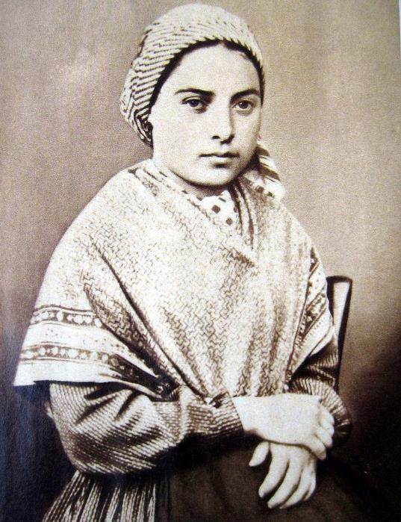

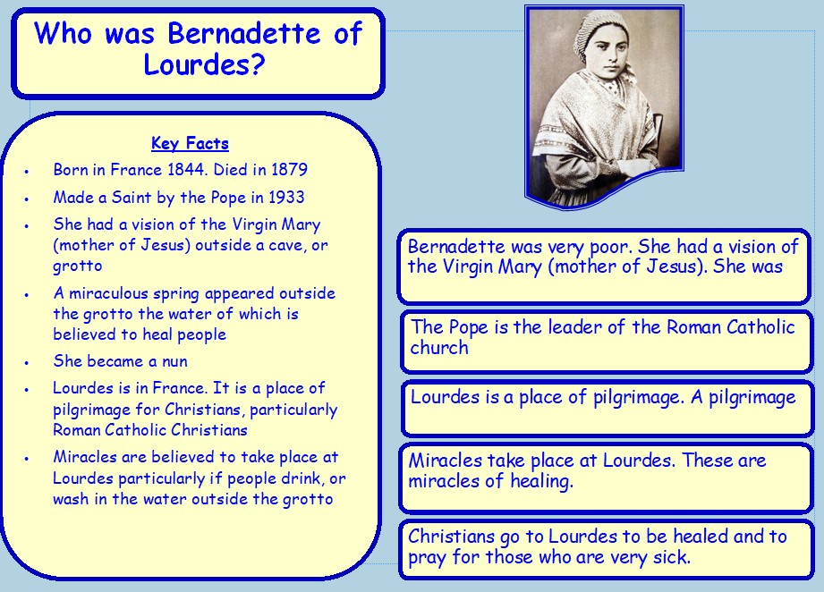

Background information – the story of Bernadette

Bernadette was born in a small town in France called Lourdes. Her family was very poor and they had to share one cold room. The only way to keep warm was to burn sticks which the children had to collect.
One cold winter's day, Bernadette, her sister and her friend were gathering firewood beside a river. They had been out all day and it was now growing dark. Both her sister and friend set off for home, crossing the icy cold river in their bare feet. Bernadette hesitated. She didn't want to cross the river because it was so cold and she felt getting her feet wet might make her ill.
Her sister and friend called to her from the other side of the river. Bernadette was just about to follow them across, when she heard the sound of a great wind. She looked round and out of a cave, or grotto, in the rock, came a beautiful young lady. She wore a sparkling white dress, blue sash, veil and carried a rosary. She smiled at Bernadette and beckoned to her to come closer. Bernadette could not believe what she was seeing but she was not afraid. She knelt down and began to pray. The lady prayed with her. After a while the lady disappeared.

Her sister and friend returned to find Bernadette kneeling. They urged her to hurry across the river. Bernadette put her foot in the water. It felt warm. On the way home, Bernadette told them about the beautiful lady. They didn't believe her. Bernadette's mum did not believe her either. "Such nonsense!" she said, "you are never to go back to that cave again".
Bernadette pleaded with her mum and, after three days, she was allowed to return to the cave. She saw the beautiful lady and, again, they prayed together. After that, Bernadette went to pray with the lady, day after day. People got to hear about Bernadette and her vision of the beautiful lady and large crowds followed her to the cave. But no one, except Bernadette, could see the vision of the beautiful lady.
One day 300 people had gathered when Bernadette went to the cave. As before, the beautiful lady appeared to Bernadette. This time she told her to dig a hole in the ground, drink the water and bathe in it.
Bernadette looked around but could see no water, so she started scratching away at the mud beneath her feet. As she scratched at the mud, she was amazed to find a tiny trickle of water, so she did what she was told, cupped her hands and drank the muddy water. The people watching were disgusted, for again, they saw no beautiful lady – only Bernadette, drinking muddy water!
And as Bernadette drank she was amazed as the trickle of water became a steadier trickle and then slowly turned into a spring. The lady told her that this would be a spring to heal people of their illnesses. She asked Bernadette to build a chapel by the side of the spring, which is just what she did.
Bernadette found out who this beautiful lady was only on the very last time that she appeared.
“Who are you?” asked Bernadette.

“I am Mary, the mother of Jesus.”
Bernadette fell to her knees in a tremble. When she looked up, Mary had vanished.
Some people said Bernadette was mad and laughed at her. Others said she was lying and shouted at her. She was slapped and spat upon. She was spoken to by her teacher, her priest, the local police and other important people who came all the way from Paris. All of these people wanted Bernadette to say


Bernadette answered all their questions in a quiet, gentle way. But she would not give up her belief that her vision of the beautiful lady was real.
And to this day, ill people travel to Lourdes in France to the stream which still trickles. They drink and bathe in the waters there in the hope that they will be healed. There are many stories of people being healed at the waters of Lourdes and millions travel there each year on pilgrimage.

Window: Exploring the story of Bernadette and Miracles
- Find out what the word miracle means. Write you own meaning of it.
- Imagine you were Bernadette’s friend. Write your own diary account of the events that happened to Bernadette and how you felt about it all.
- Jesus performed miracles. We will only look at a nature miracle. Read the following nature miracle that Jesus did.

Jesus calms the storm Mark 4:35-41
You can find this on YouTube: https://www.youtube.com/watch?v=ZzPwRXytr7U
That evening, Jesus said to his followers, “Come with me across the
lake.” 36 He and the followers left the people there. They went in the boat that Jesus was already sitting in. There were also other boats with them. 37 A very strong wind came up on the lake. The waves began coming over the sides and into the boat. It was almost full of water. 38 Jesus was at the back of the boat, sleeping with his head on a pillow. The followers went to him and woke
him. They said, “Teacher, do you care about us? We will drown!”
39 Jesus stood up and commanded the wind and the waves to stop. He said, “Quiet! Be still!” Then the wind stopped, and the lake became calm.
40 Jesus said to his followers, “Why are you afraid? Do you still have no faith?”
41 The followers were very afraid and asked each other, “What kind of man is this? Even the wind and the waves obey him!”


- What kind of miracle do you think this was? Why

- What powers does Jesus have in this miracle?

- Who do you think Jesus was – ‘What kind of man is this?’

- Why do you think the disciples (followers of Jesus) were afraid?

- What sort of miracle did Bernadette experience? Nature or healing? Can you explain your reasons?

- Can you find out any other nature miracles that Jesus did? Find out about these nature miracles in the Gospel of John 6 v 1-15; Matthew 14:
22-33; John 2: 1-11. Create a poster or story board that tells what happened at one of these miracles. If you are good at IT you could create a cartoon, or you could use symbols to retell the miracle.

Challenge yourself
  - Imagine you were one of the disciples in the boat with Jesus when he calmed the storm. Describe how you felt as the storm raged around you and how you felt when Jesus calmed the storm.
My name is Peter and I was in the boat he night when Jesus calmed the storm. That night…

  - The disciples were frightened and fearful until Jesus calmed the storm. Think of the values of courage and faith. What do these words mean? When have you showed courage and faith in your life?
I showed courage when I I showed faith when I

  - Why do you think it is right to do to remain calm in times of trouble, ridicule and difficulty? Think of the story of Bernadette and what Jesus said to his disciples in the boat, “Why are you afraid? Do you still have no faith?”

YouTube videos

Jesus feeds the 5000: https://www.youtube.com/watch?v=S6rj9cAJrWE
Jesus walks on water: https://www.youtube.com/watch?v=oVy9HGr3Qig
Jesus turns water into wine: https://www.youtube.com/watch?v=7plJa_qnVug&t=17s

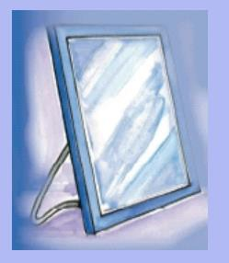
Mirrors: What does the story of Bernadette and the miracles mean for Christians?

Miracles tell Christians something about who Jesus is. Jesus performed many miracles when he was on earth. His most famous were miracles of healing and his nature miracles. Christians believe that these miracles prove that Jesus was more than just an ordinary human being. They believe that Jesus was the incarnation of God on earth (God being born as a human being). Performing miracles showed people that Jesus had the power of God working in and through him.

- What do Christians believe miracles suggest about Jesus?

- What does the word incarnation mean?

Challenge yourself
- Can you find out any other nature miracles that Jesus did? Find out about these nature miracles in the Gospels of John 6 v 1-15; Matthew 14: 22-33; John 2: 1-11. What do you think these miracles teach Christians about Jesus?

- Imagine you are a newspaper journalist for the Galilee Post. You have just witnessed one of these miracles. Write a newspaper article describing what you saw. You could include an imaginary interview. Finish by saying what you think the miracle suggested Jesus might be.



Door – What have I learnt from the story of Bernadette and the miracles of Jesus? What could I do?
Many Christians today believe that miracles can still happen. They also believe in the power of prayer. Many Christians believe that healing and prayer go together.

Read the following modern day miracle:
The end of Grayson Kirby seemed inevitable when he was thrown from a car. The accident left him in a coma. His lungs were crushed and nearly every other bone in his body was broken. The chances of him surviving were slim.

But his family refused to give up and turned to prayer. Thousands of people in the community and beyond kept Kirby in their thoughts and prayers and wore red shirts designed to show support for the injured man.

In a final attempt to revive Kirby, doctors hooked him up to a machine to try a revive him. Whether it was due to God and the power of prayer or the doctors (or both), it worked.

Ten days after the accident, Kirby opened his eyes and mouthed the words, “I love you,” to his father.

The doctors couldn’t believe it, and neither could Kirby.

“I’m humble, I’m grateful, just amazed.” Kirby said. “I know that God saved me. I know that prayer and believing saved me.”

  - Create a prayer paper chain. On each link of your chain write a prayer for someone you know who is ill; for someone in need; for the world; for your friends and family. The list could go on. Use it to pray for others.

