Supporting Dora Rose Care Home
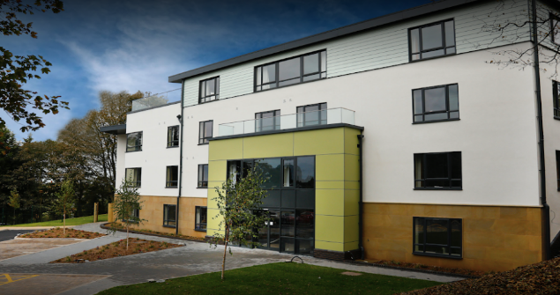
We have been asked to bring some of our Christmas cheer to the Dora Rose Care Home at Milford.
Please make one of these decorations at home.
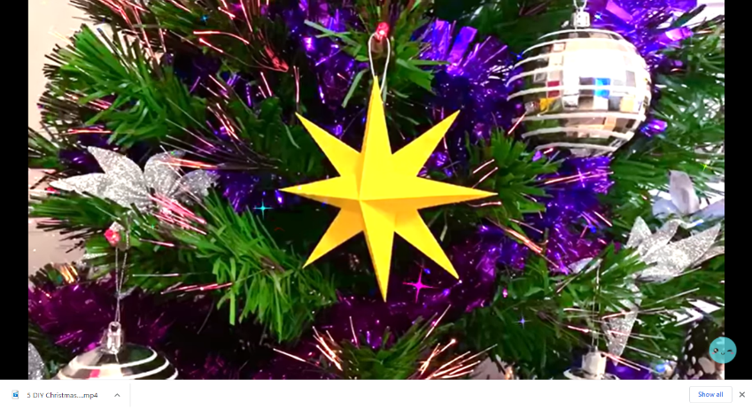
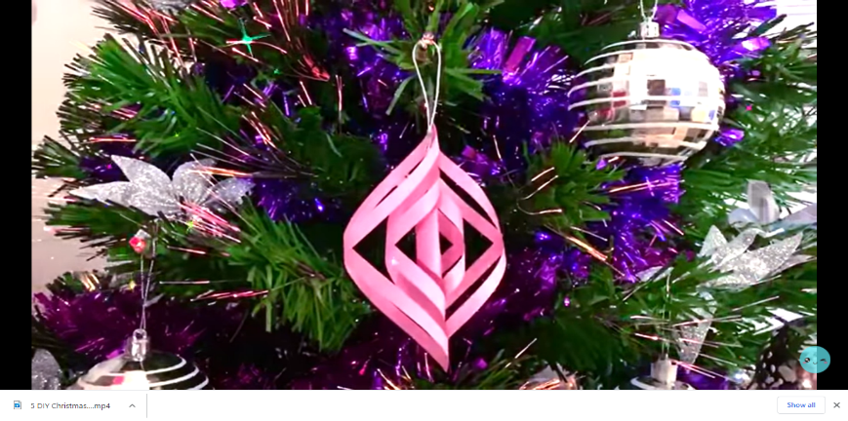
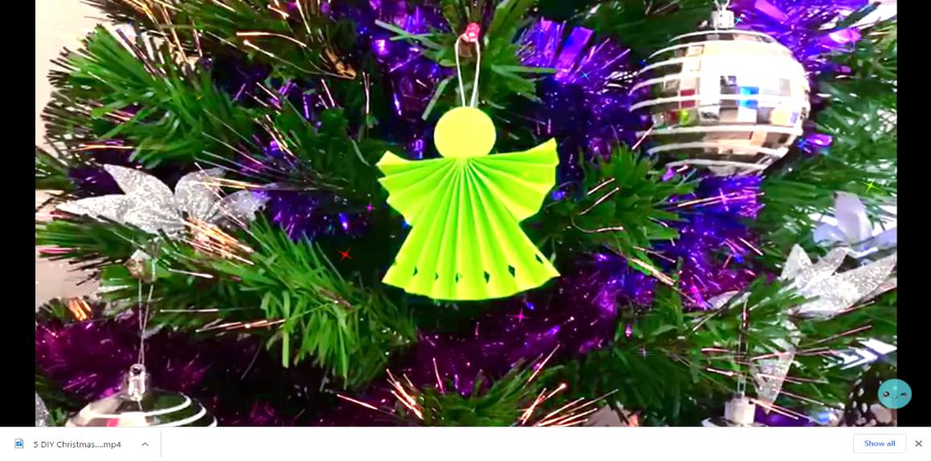
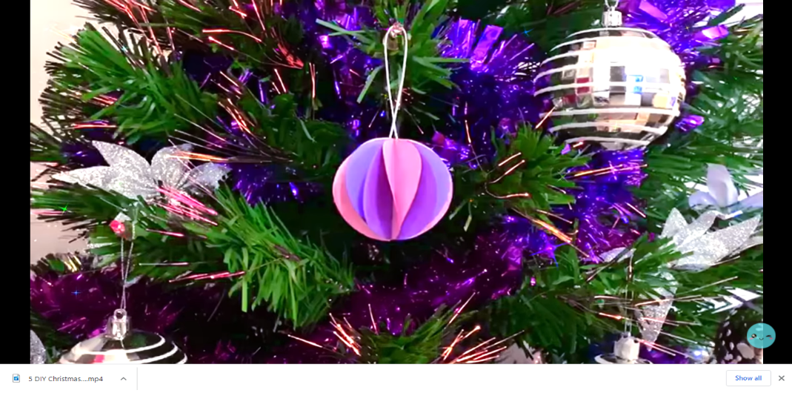
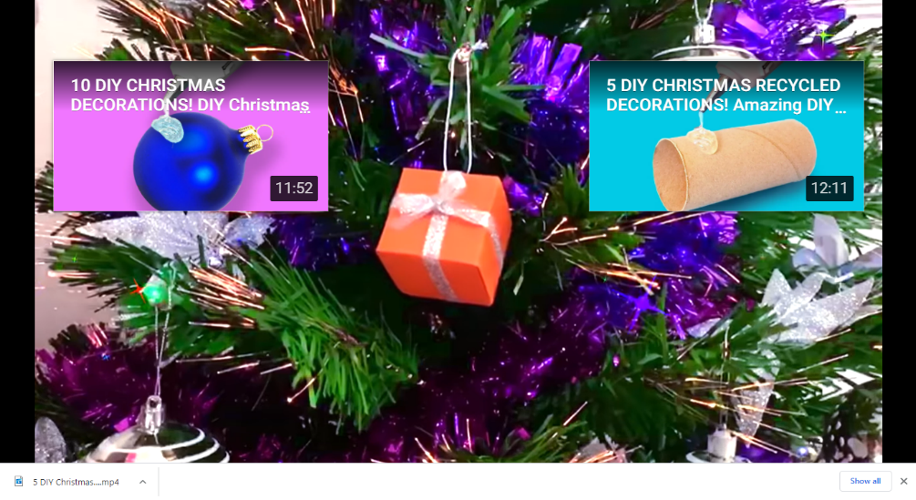

They are all easier than they look. Click on the photos to link to a video showing you how to create each one. You only need to make one, but can make as many as you want.
This is the link if clicking the picture doesn’t work. https://berkswich-ce-vc-primary-school.primarysite.media/media/year-six-dora-rose-crafts
If you don't have coloured paper, please don't worry. You can use magazines or newspapers if you'd like to make one from recycled resources. Alternatively, use plain paper and decorate it first with pens or colouring pencils.
Please bring your design back to school on your first day back; there will be a box to drop it in.
Thank you: your creation will bring a smile to staff and residents at Dora Rose.

