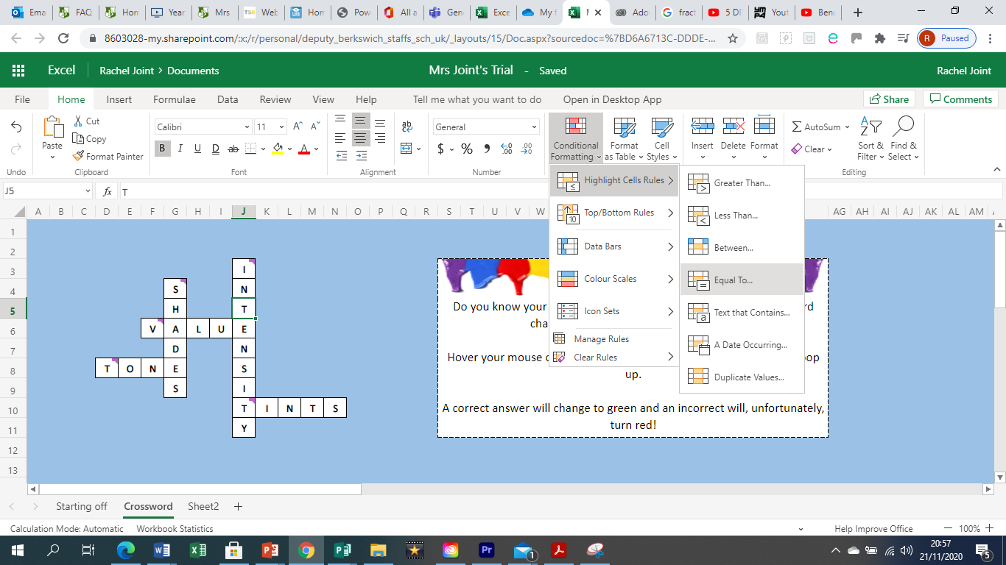
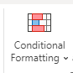
⇒ Then choose ‘Hightlight Cells Rules’ because you need to make a new rule for this cell.
⇒ Once you have clicked on this, then see if you can work out what to click next to make correct answers change colour. You want the changes to equal to the letter that is in the cell you selected.

Being Excel-lent Again!
⇒ Select a cell with one of your crossword letters in and then click on conditional formatting. This will allow you to change the formatting based on a condition that you set.
⇒ Check that your puzzle works by deleting the letter in the cells where you have added conditional formatting. Put the wrong letter in and it should not change colour. Add the correct one and it should turn the colour that you decided.
⇒ Repeat for each letter in your crossword puzzle. Can you copy and paste cells which have the same letter in to make your job easier and quicker?
Ctrl and C = copy
Ctrl and V = paste
⇒ Only when you have done this, can you decorate your page. Keep it simple and stylish! Maybe add a paintbrush or two.

Challenge: can you make the cells also change colour when the letter is wrong? There might be a very simple solution to this!
Challenge: can you make a ‘Click for Instructions’ button next to your crossword puzzle and hyperlink it to another sheet where your instructions are so that they are not on the puzzle page?

